City: New York City

Season: Fall-Winter

Year: 2020

Women

Ready-to-Wear

Brand Name: Peter Do

Designer Name: Peter Do

Description: Moda Operandi’s Lisa Aiken hosted a dinner for Peter Do a couple of weeks ago. The e-tailer had just launched its first Do trunk show and gathered other supporters to celebrate, but it was no ordinary fashion night out. First there was the location: a Taiwanese restaurant in Bushwick called Win Son—delicious. Then there was the karaoke party that accompanied dessert. Rare is the industry occasion when a designer belts out his favorite tune—in this case, The Backstreet Boys’s “As Long As You Love Me”—but Do is confident as hell, and determined to do things his own way, and he has good reason. Fall is his fourth collection, and he’s already landed 40 of the top stores globally.

[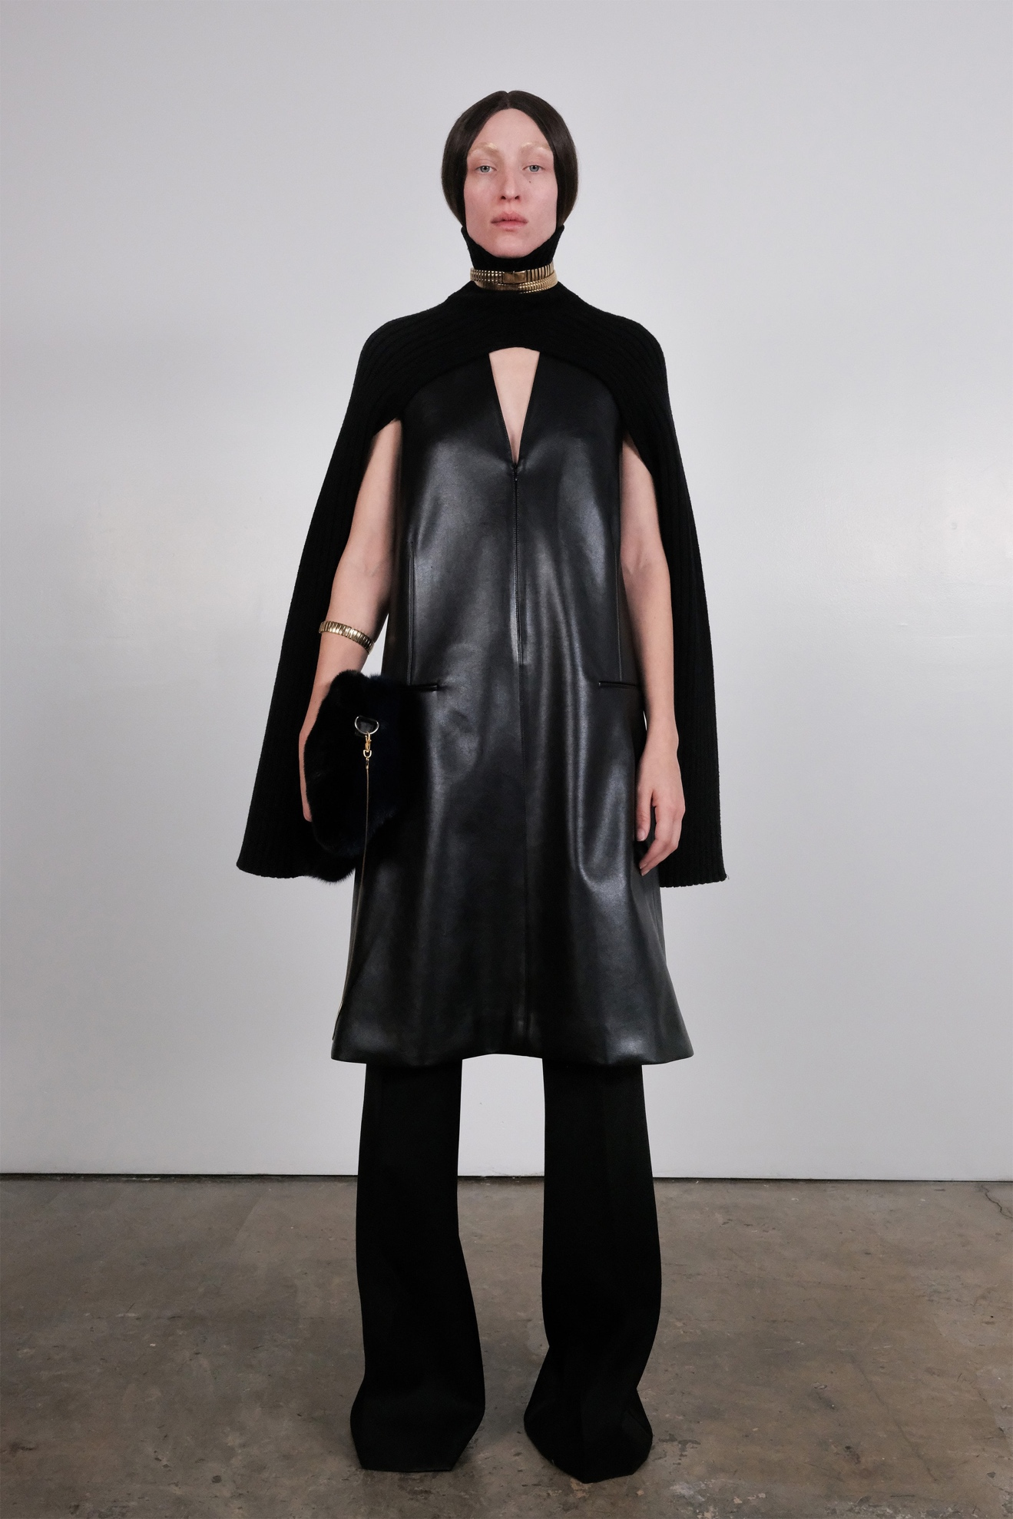Look 1](https://www.vogue.com/fashion-shows/fall-2020-ready-to-wear/peter-do/slideshow/collection#1)[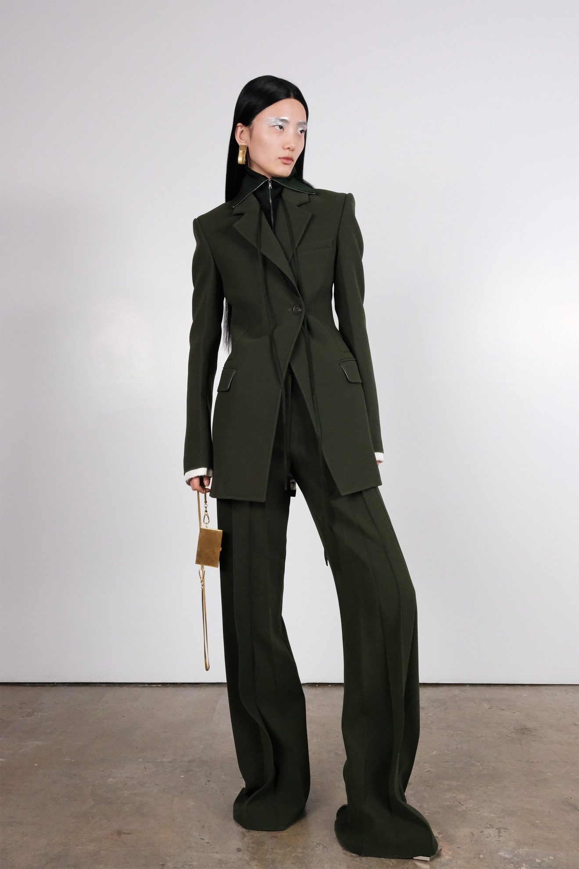Look 2](https://www.vogue.com/fashion-shows/fall-2020-ready-to-wear/peter-do/slideshow/collection#2)[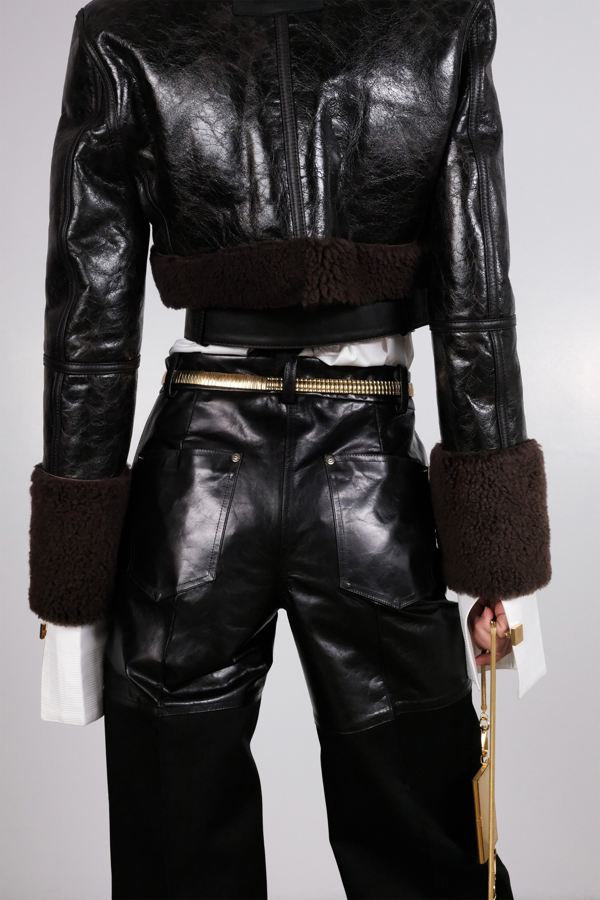Look 3](https://www.vogue.com/fashion-shows/fall-2020-ready-to-wear/peter-do/slideshow/collection#3)[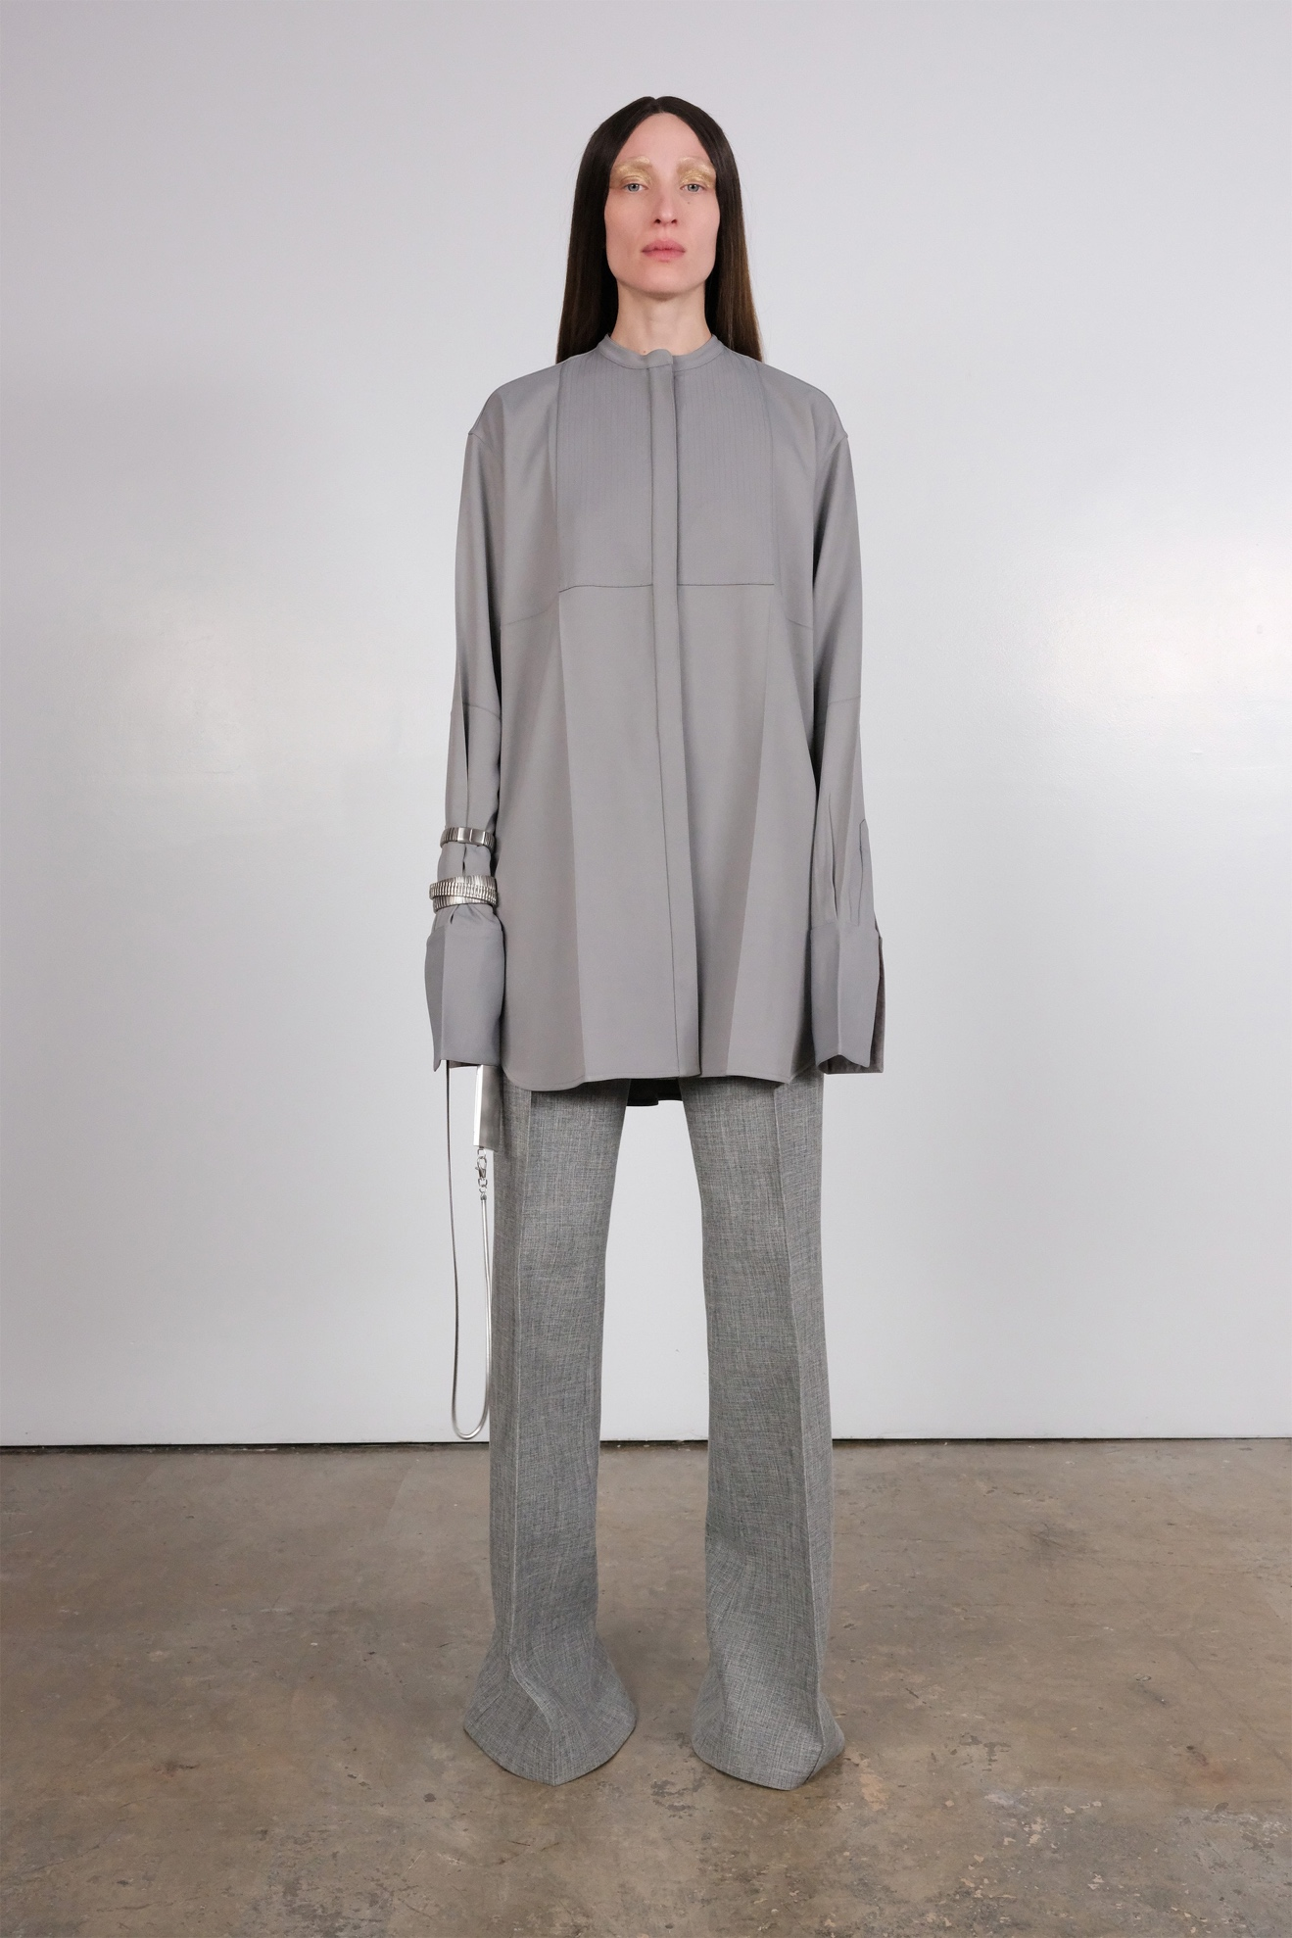Look 4](https://www.vogue.com/fashion-shows/fall-2020-ready-to-wear/peter-do/slideshow/collection#4)[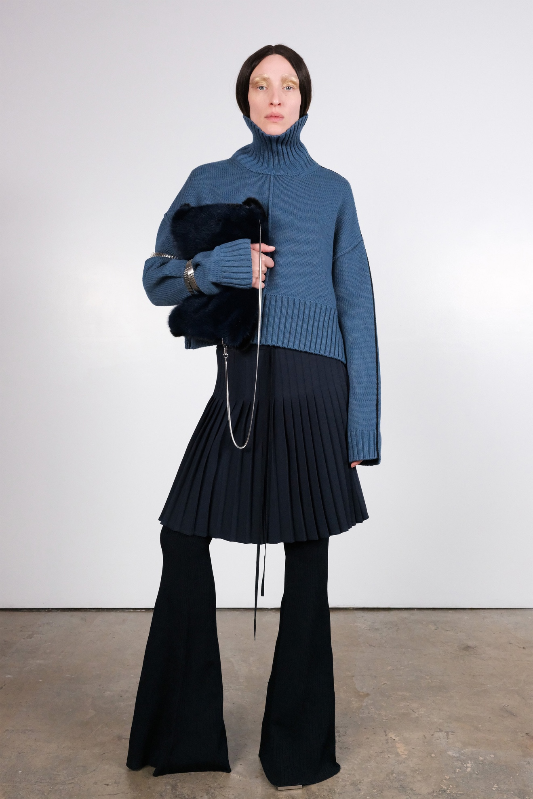Look 5](https://www.vogue.com/fashion-shows/fall-2020-ready-to-wear/peter-do/slideshow/collection#5)[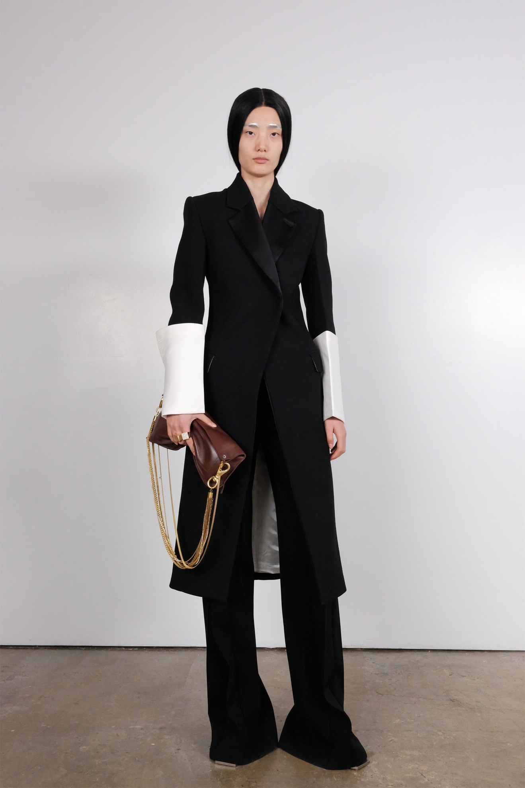Look 6](https://www.vogue.com/fashion-shows/fall-2020-ready-to-wear/peter-do/slideshow/collection#6)[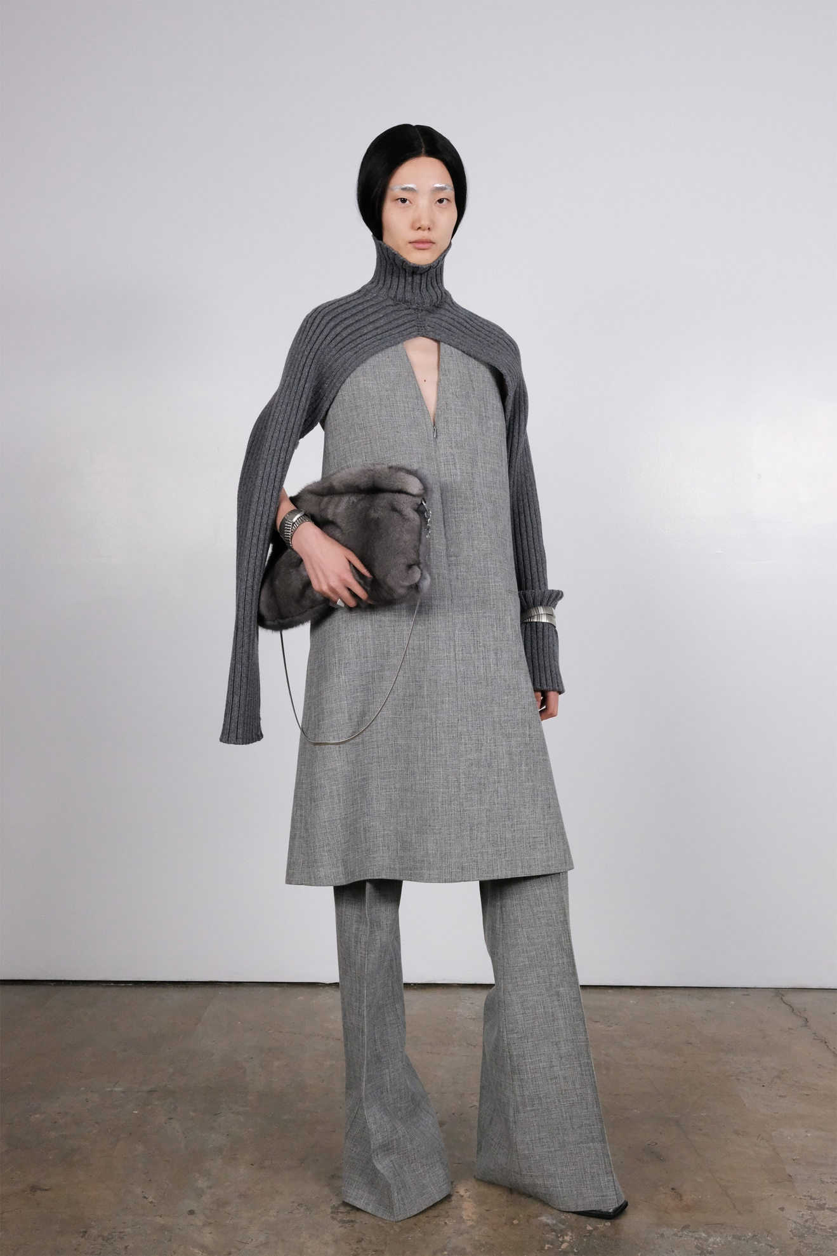Look 7](https://www.vogue.com/fashion-shows/fall-2020-ready-to-wear/peter-do/slideshow/collection#7)[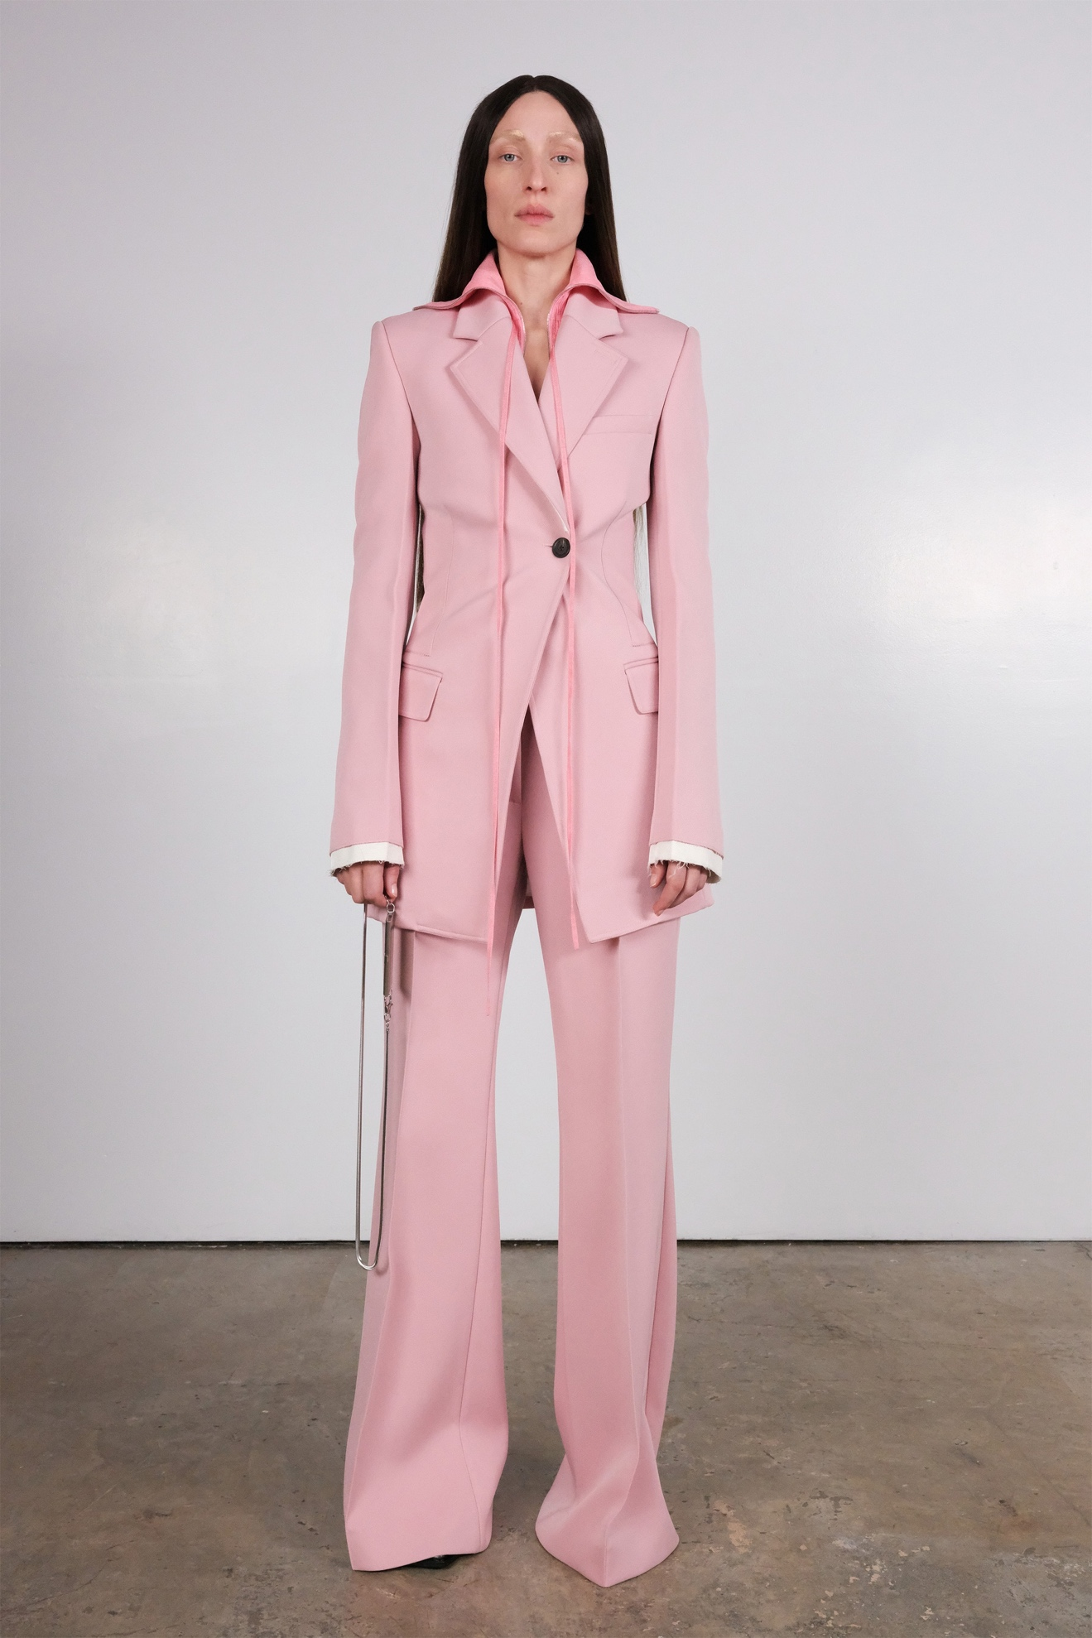Look 8](https://www.vogue.com/fashion-shows/fall-2020-ready-to-wear/peter-do/slideshow/collection#8)[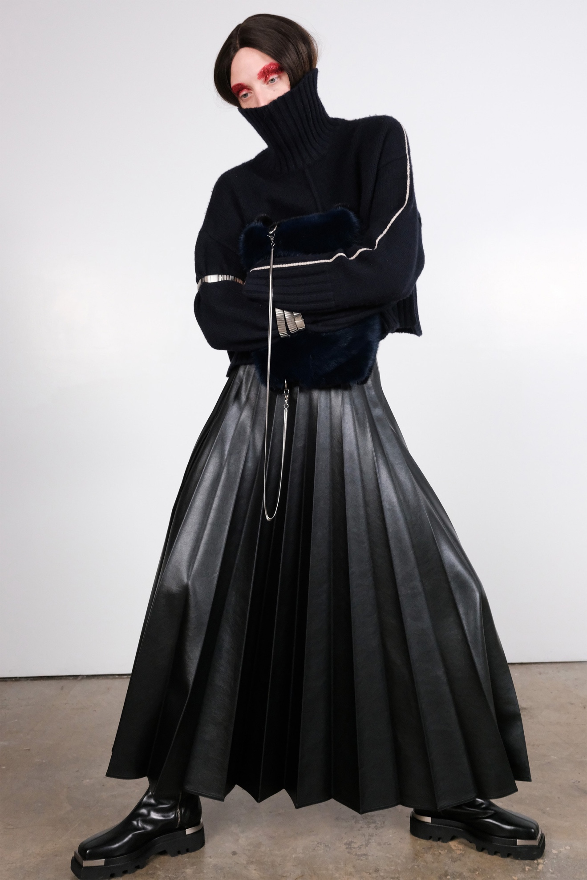Look 9](https://www.vogue.com/fashion-shows/fall-2020-ready-to-wear/peter-do/slideshow/collection#9)[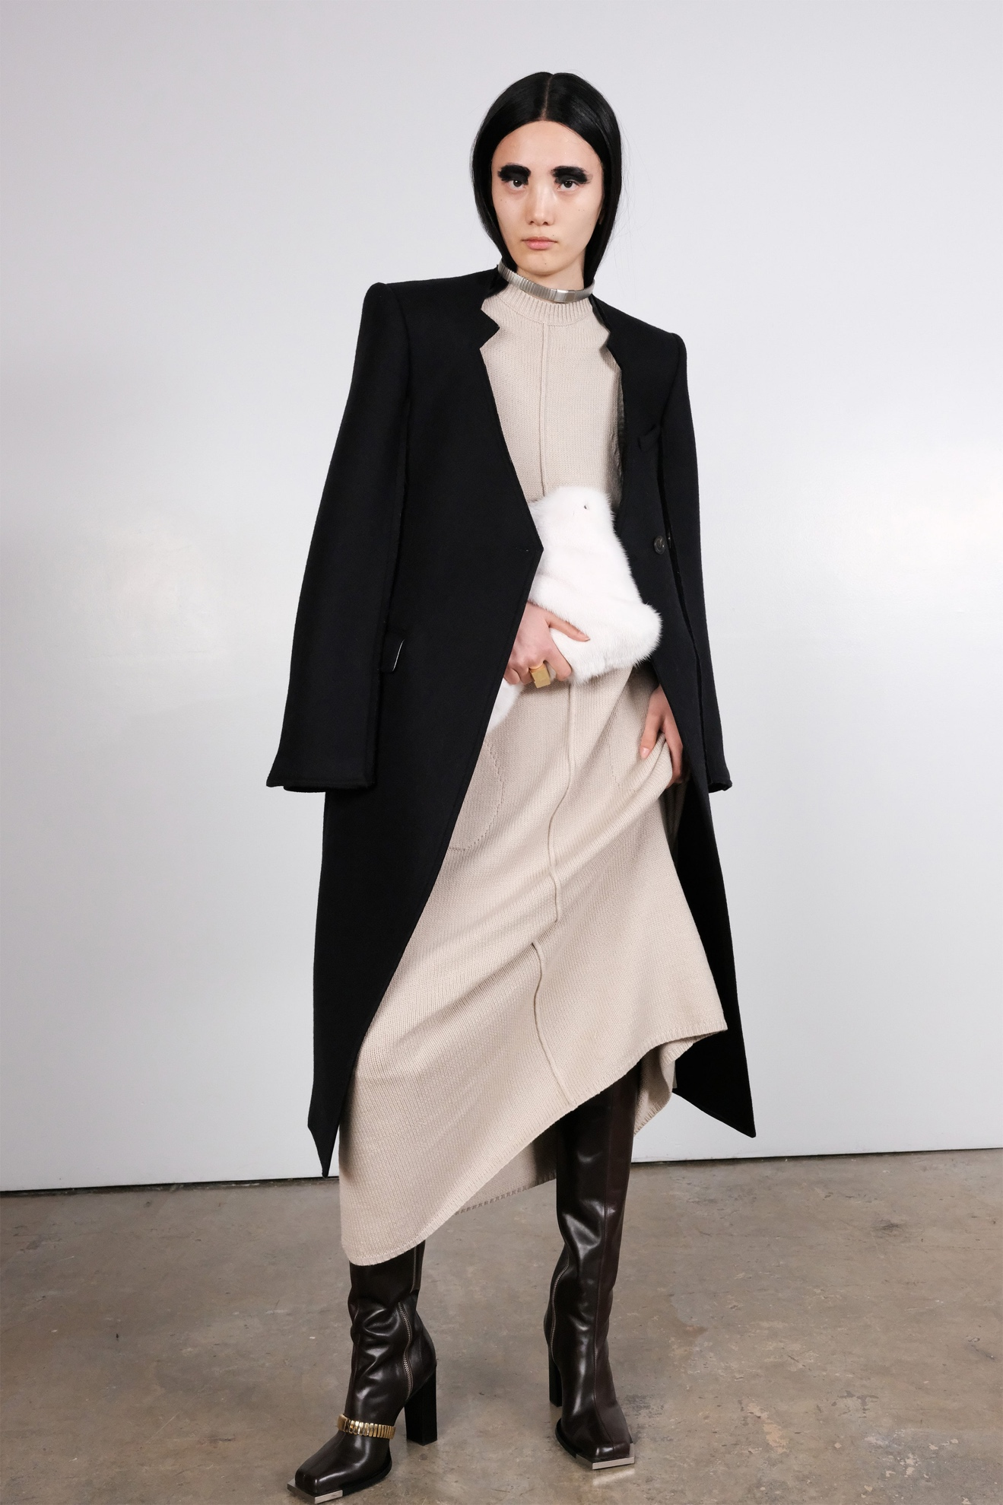Look 10](https://www.vogue.com/fashion-shows/fall-2020-ready-to-wear/peter-do/slideshow/collection#10)[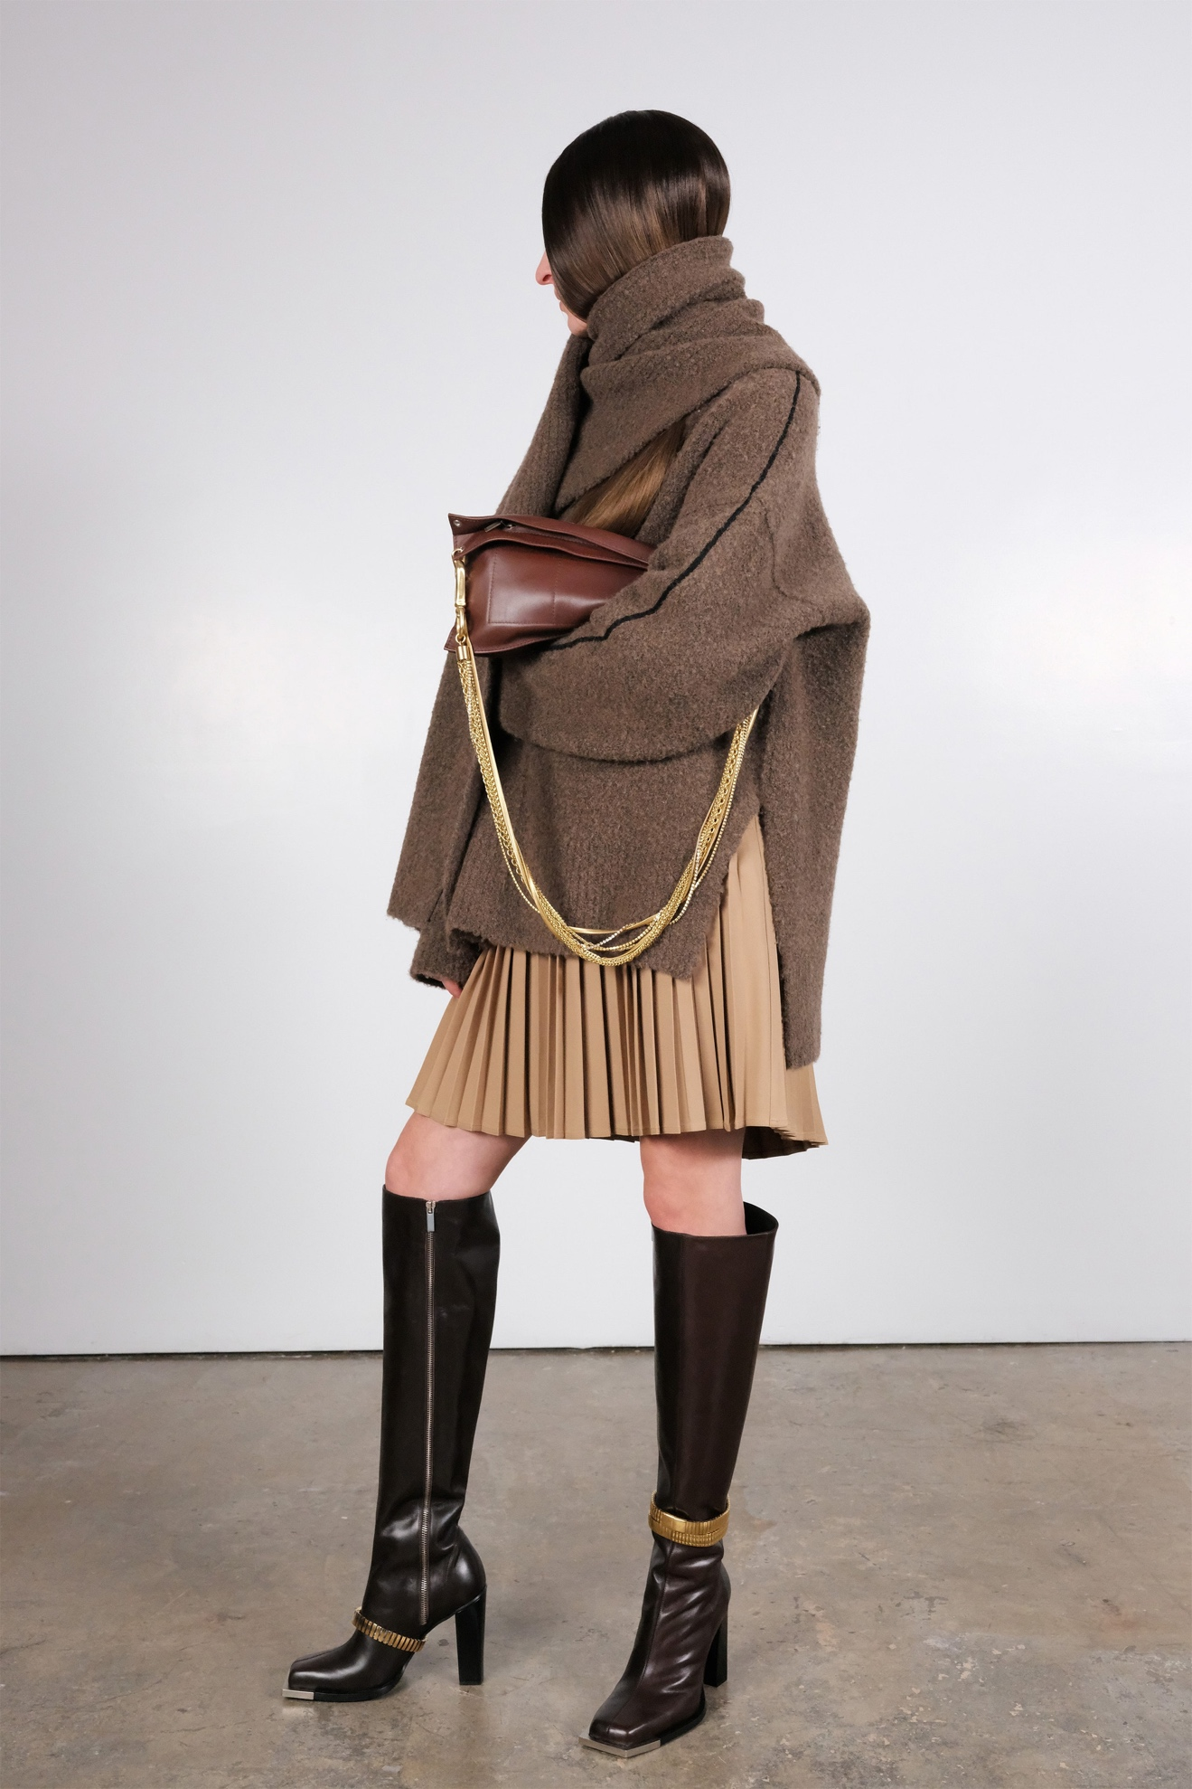Look 11](https://www.vogue.com/fashion-shows/fall-2020-ready-to-wear/peter-do/slideshow/collection#11)[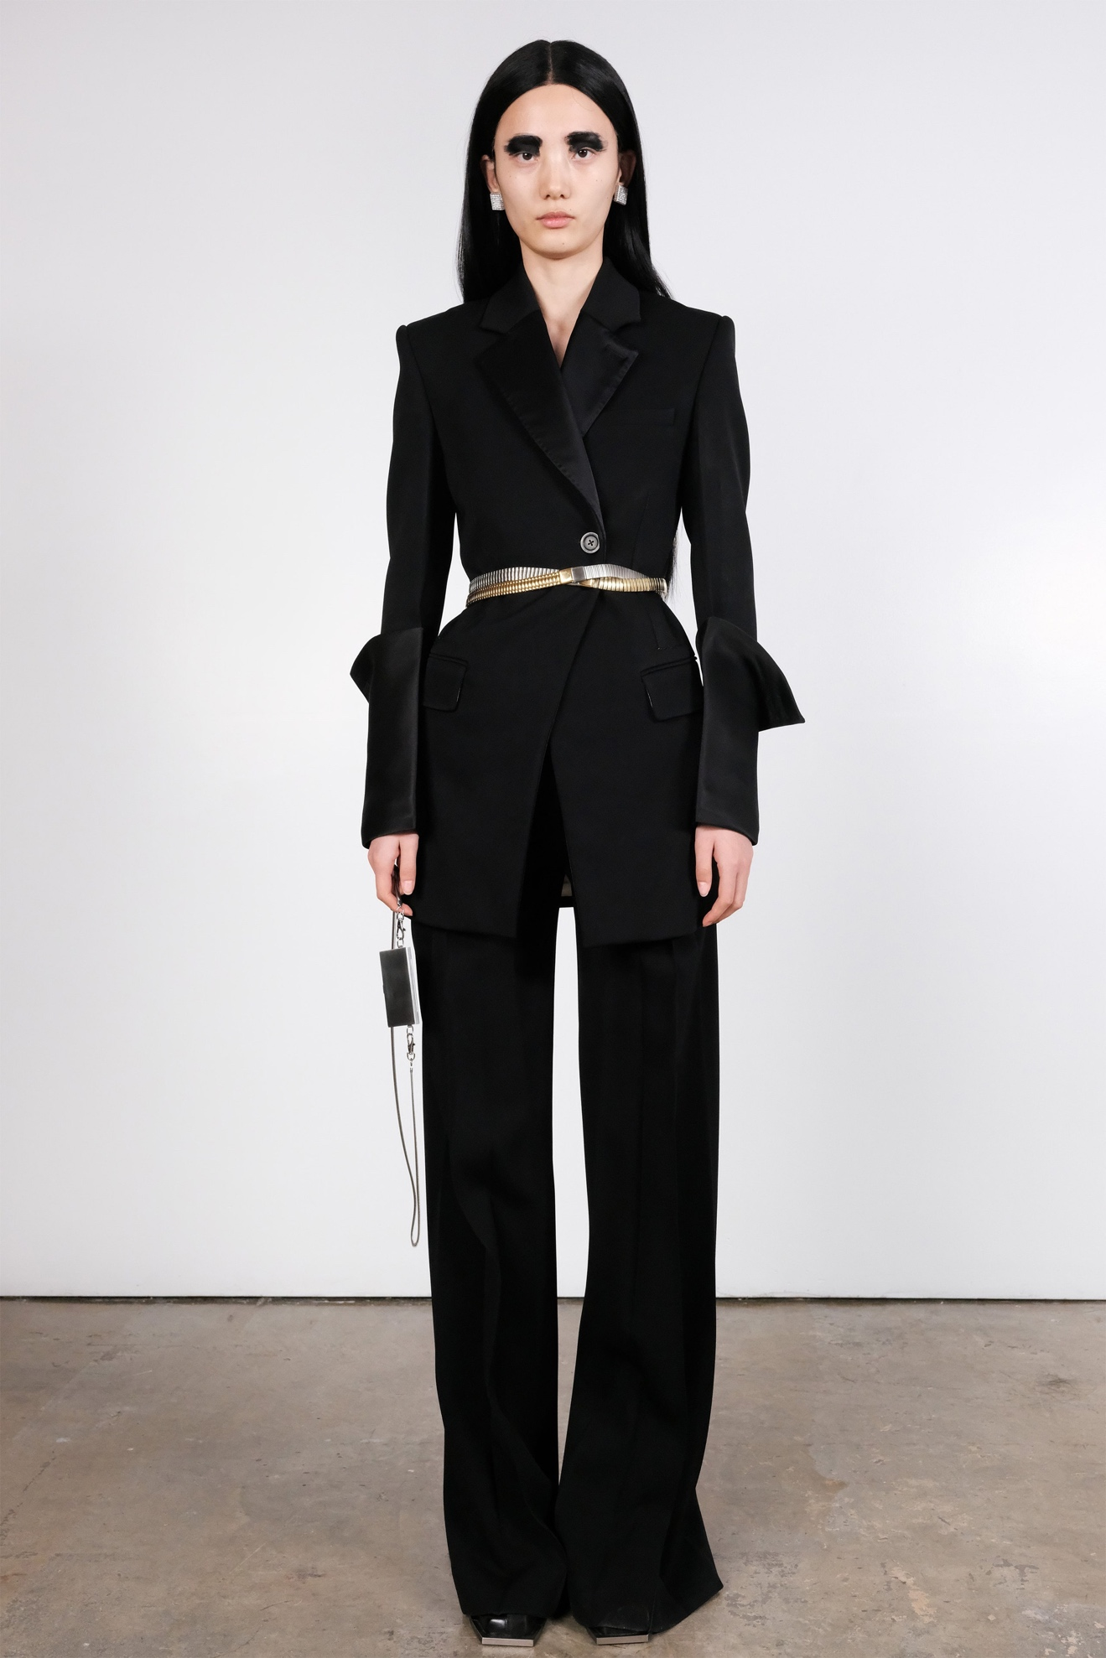Look 12](https://www.vogue.com/fashion-shows/fall-2020-ready-to-wear/peter-do/slideshow/collection#12)[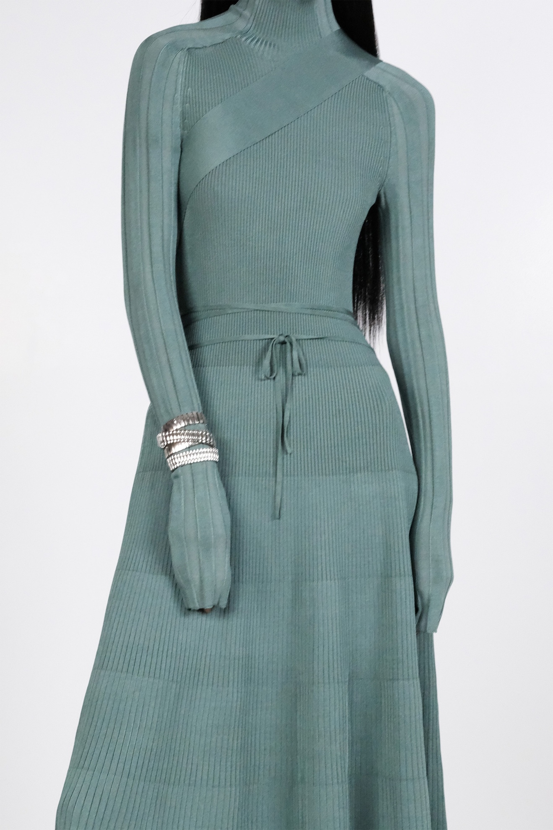Look 13](https://www.vogue.com/fashion-shows/fall-2020-ready-to-wear/peter-do/slideshow/collection#13)[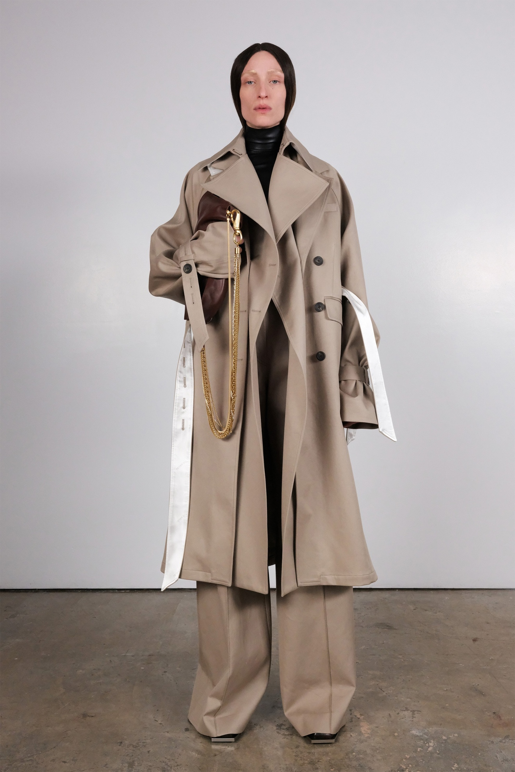Look 14](https://www.vogue.com/fashion-shows/fall-2020-ready-to-wear/peter-do/slideshow/collection#14)[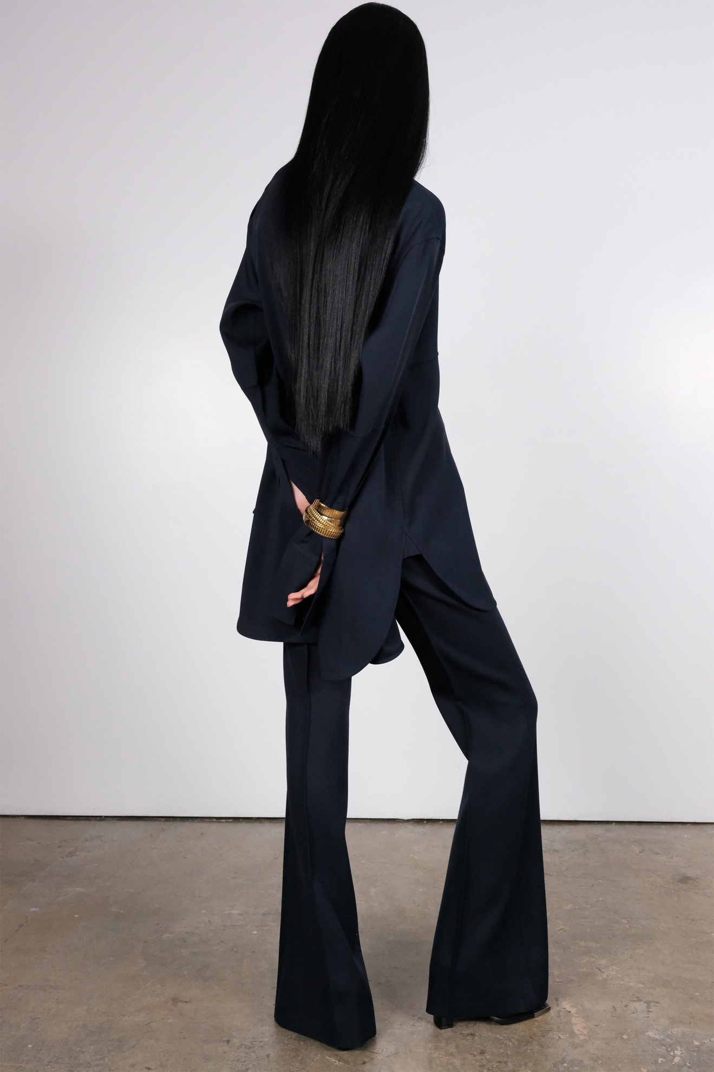Look 15](https://www.vogue.com/fashion-shows/fall-2020-ready-to-wear/peter-do/slideshow/collection#15)[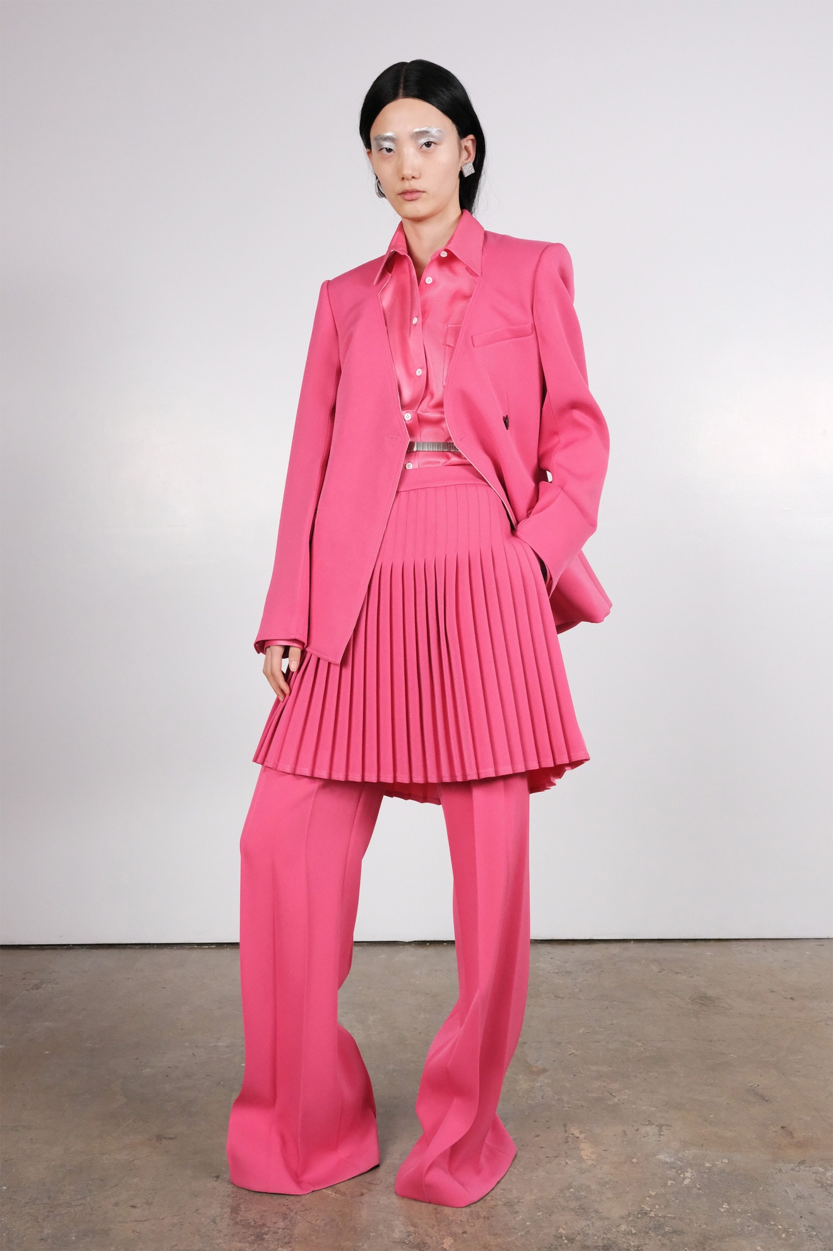Look 16](https://www.vogue.com/fashion-shows/fall-2020-ready-to-wear/peter-do/slideshow/collection#16)[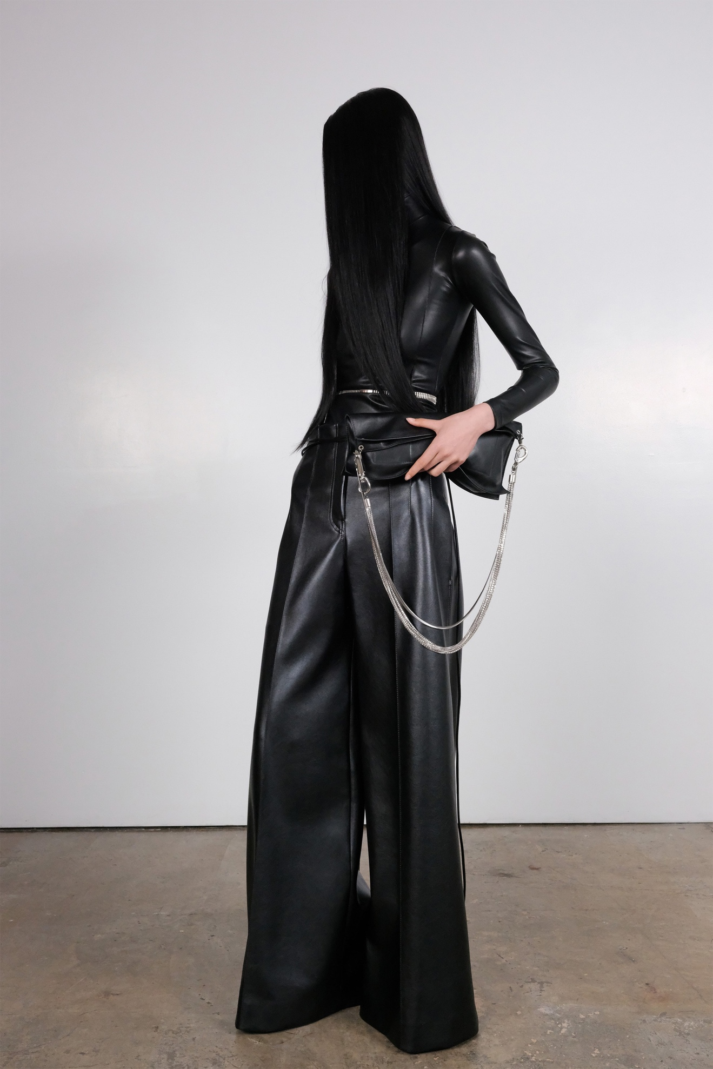Look 17](https://www.vogue.com/fashion-shows/fall-2020-ready-to-wear/peter-do/slideshow/collection#17)[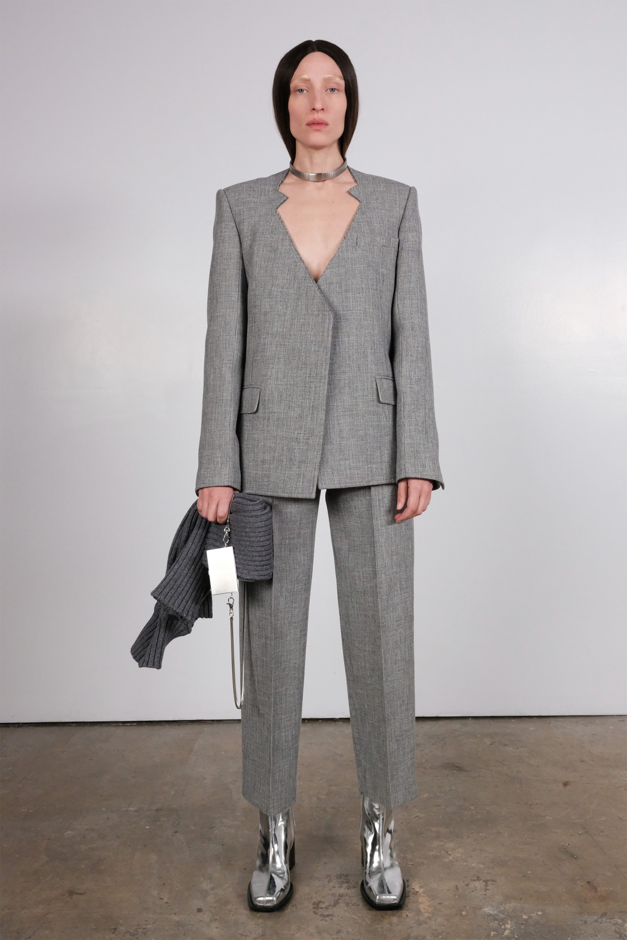Look 18](https://www.vogue.com/fashion-shows/fall-2020-ready-to-wear/peter-do/slideshow/collection#18)[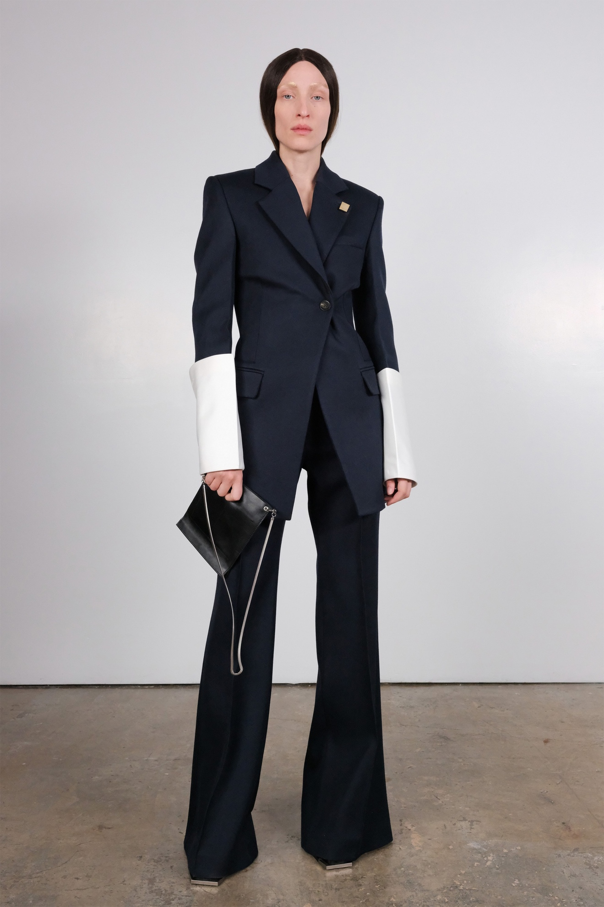Look 19](https://www.vogue.com/fashion-shows/fall-2020-ready-to-wear/peter-do/slideshow/collection#19)[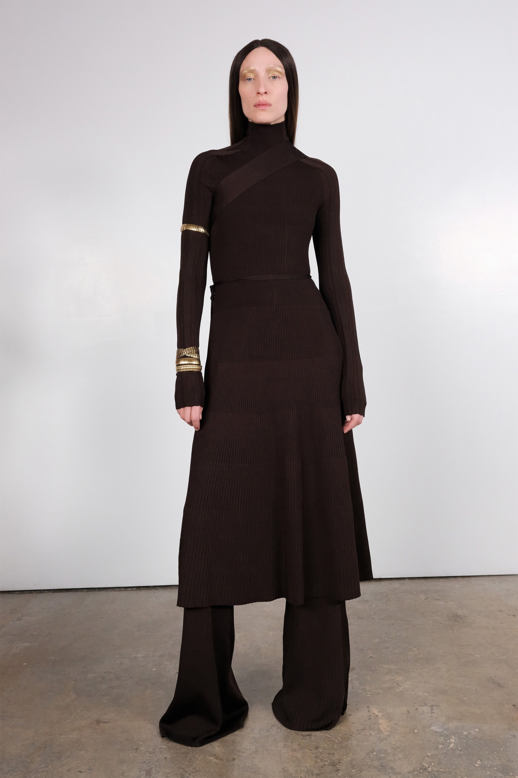Look 20](https://www.vogue.com/fashion-shows/fall-2020-ready-to-wear/peter-do/slideshow/collection#20)[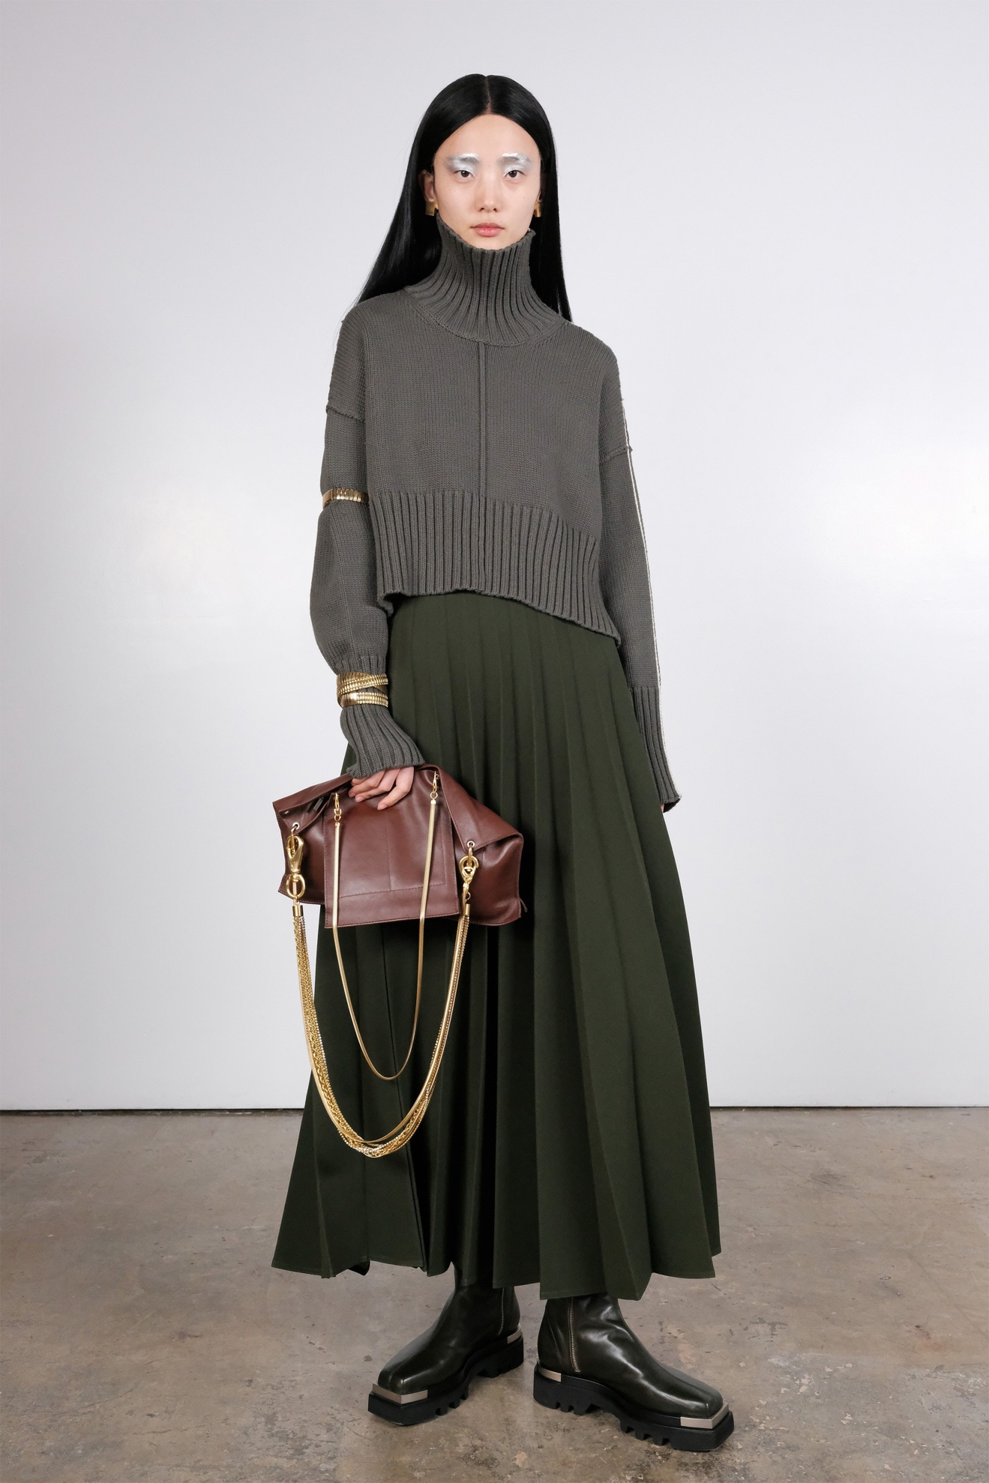Look 21](https://www.vogue.com/fashion-shows/fall-2020-ready-to-wear/peter-do/slideshow/collection#21)[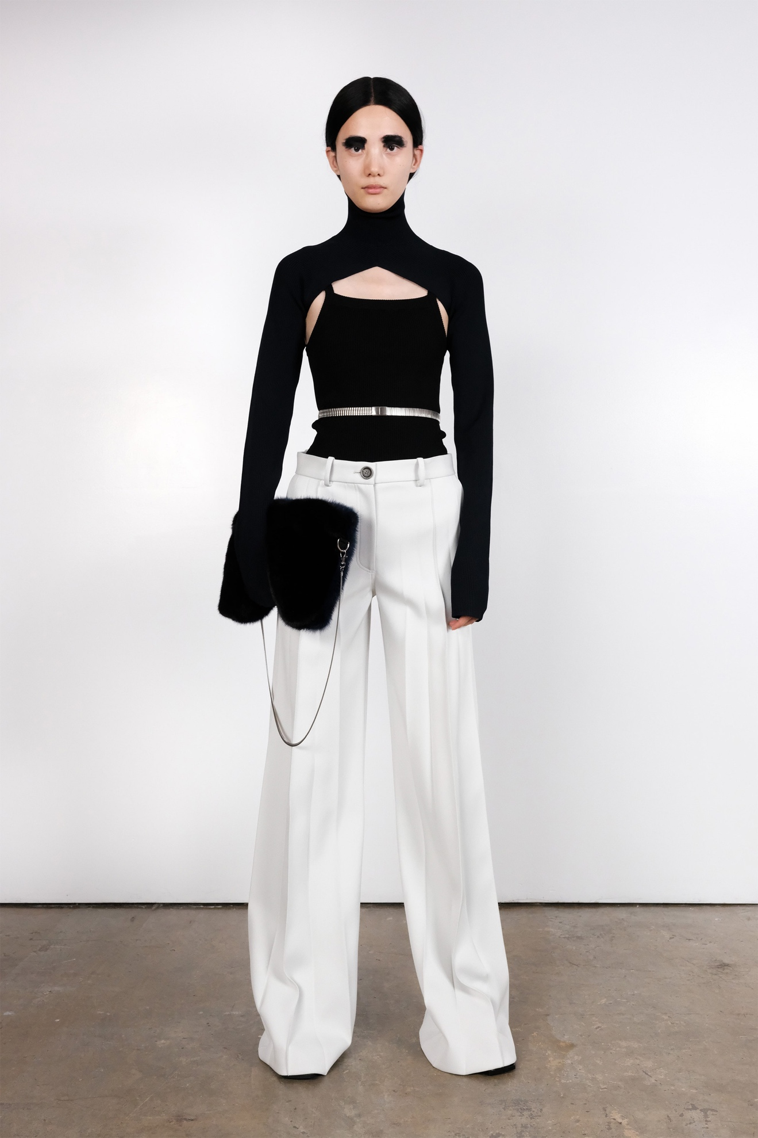Look 22](https://www.vogue.com/fashion-shows/fall-2020-ready-to-wear/peter-do/slideshow/collection#22)[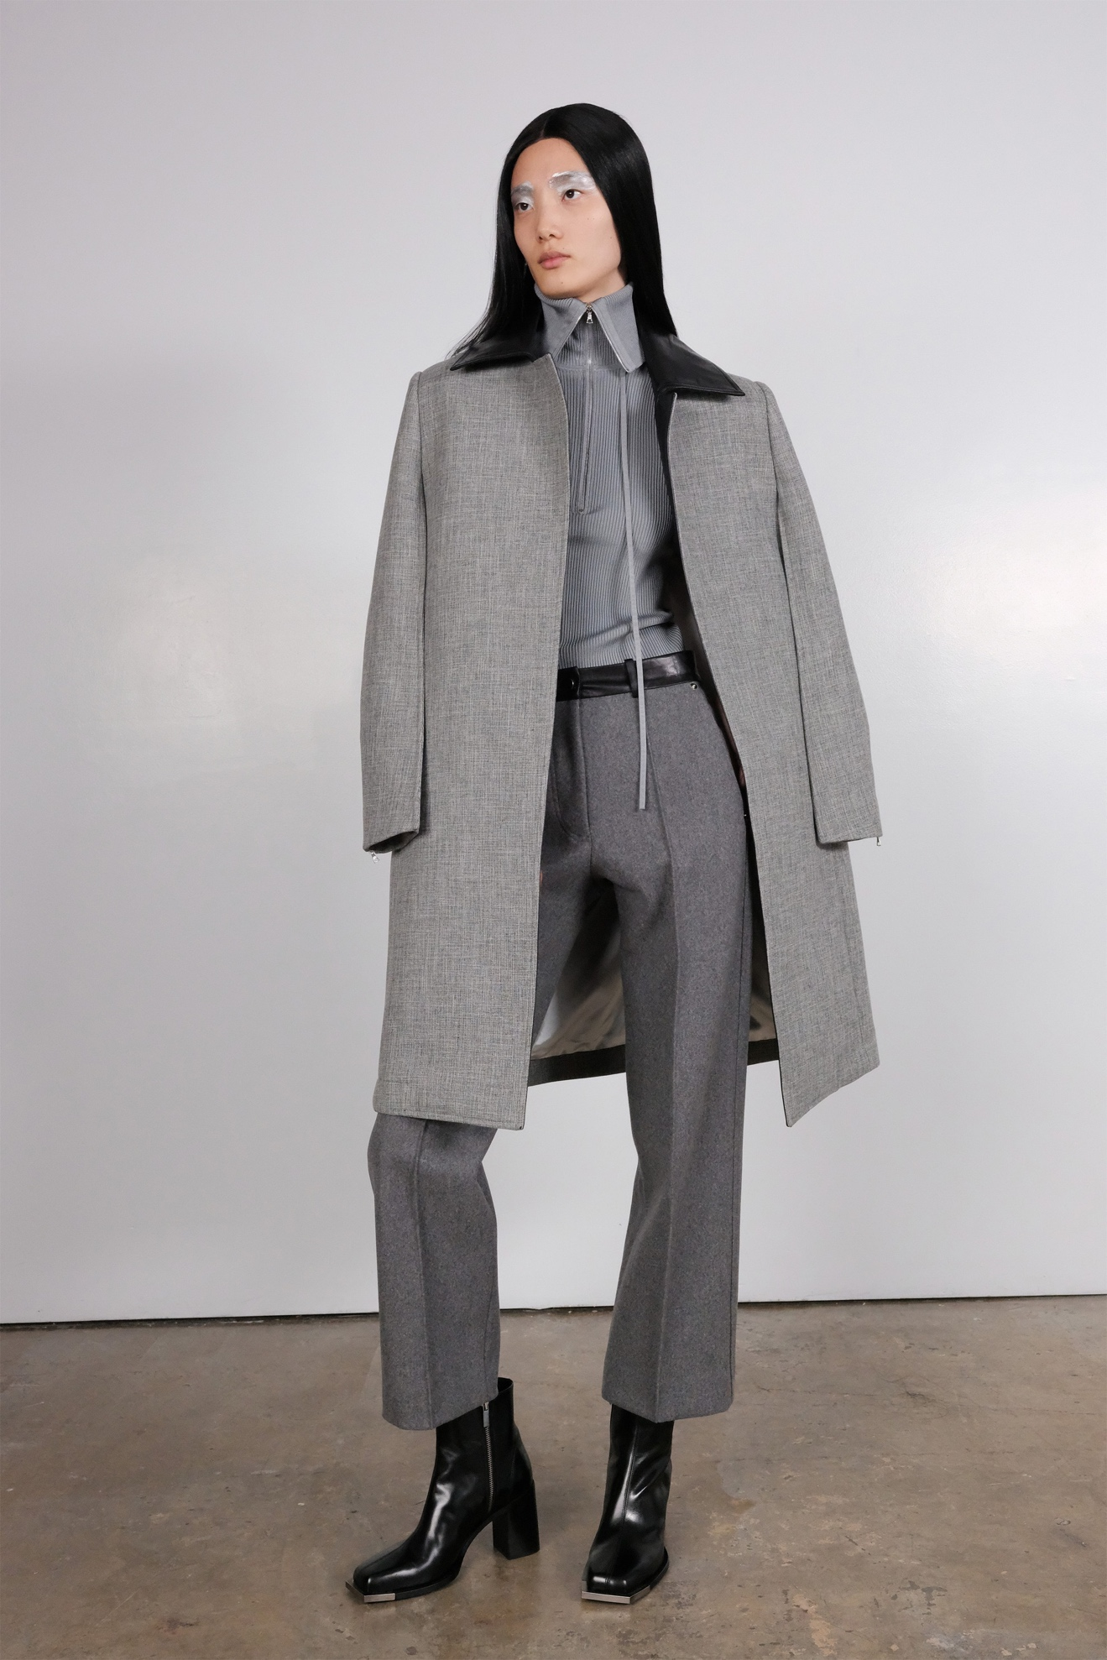Look 23](https://www.vogue.com/fashion-shows/fall-2020-ready-to-wear/peter-do/slideshow/collection#23)[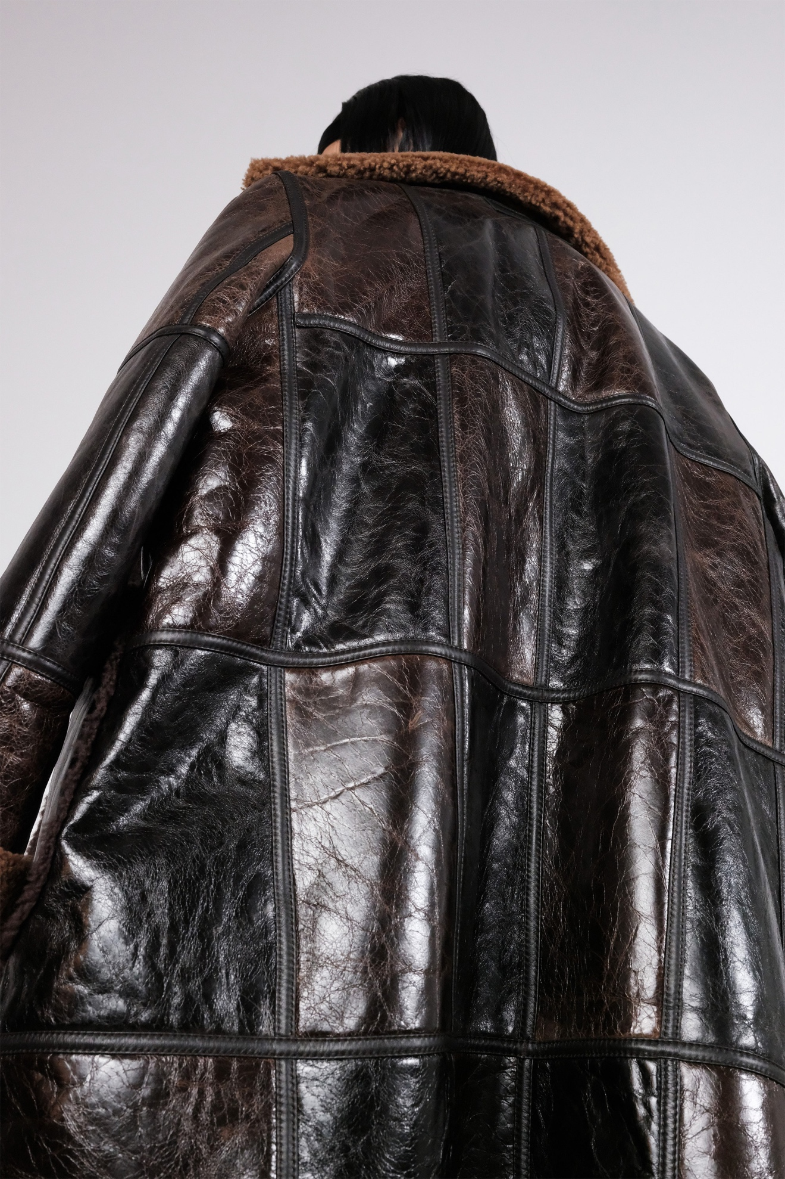Look 24](https://www.vogue.com/fashion-shows/fall-2020-ready-to-wear/peter-do/slideshow/collection#24)[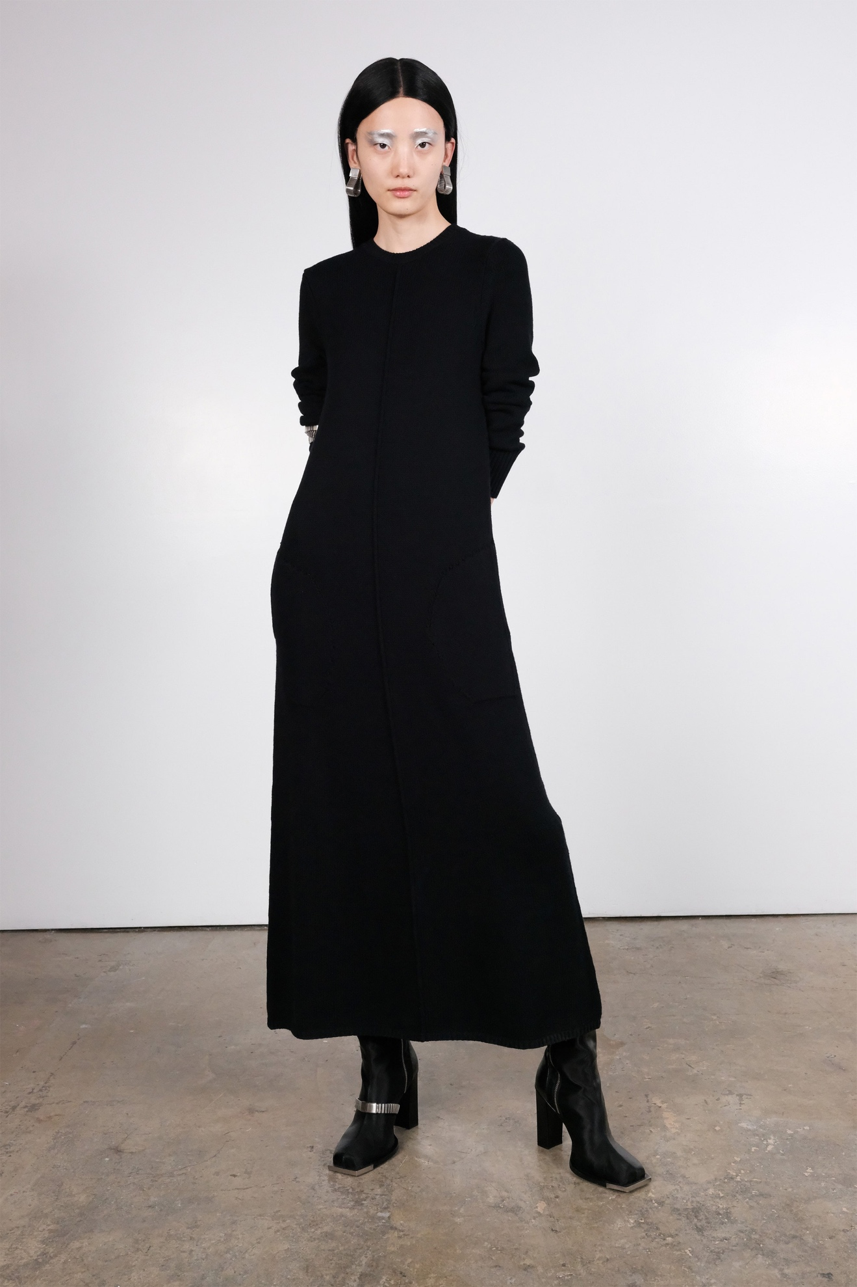Look 25](https://www.vogue.com/fashion-shows/fall-2020-ready-to-wear/peter-do/slideshow/collection#25)[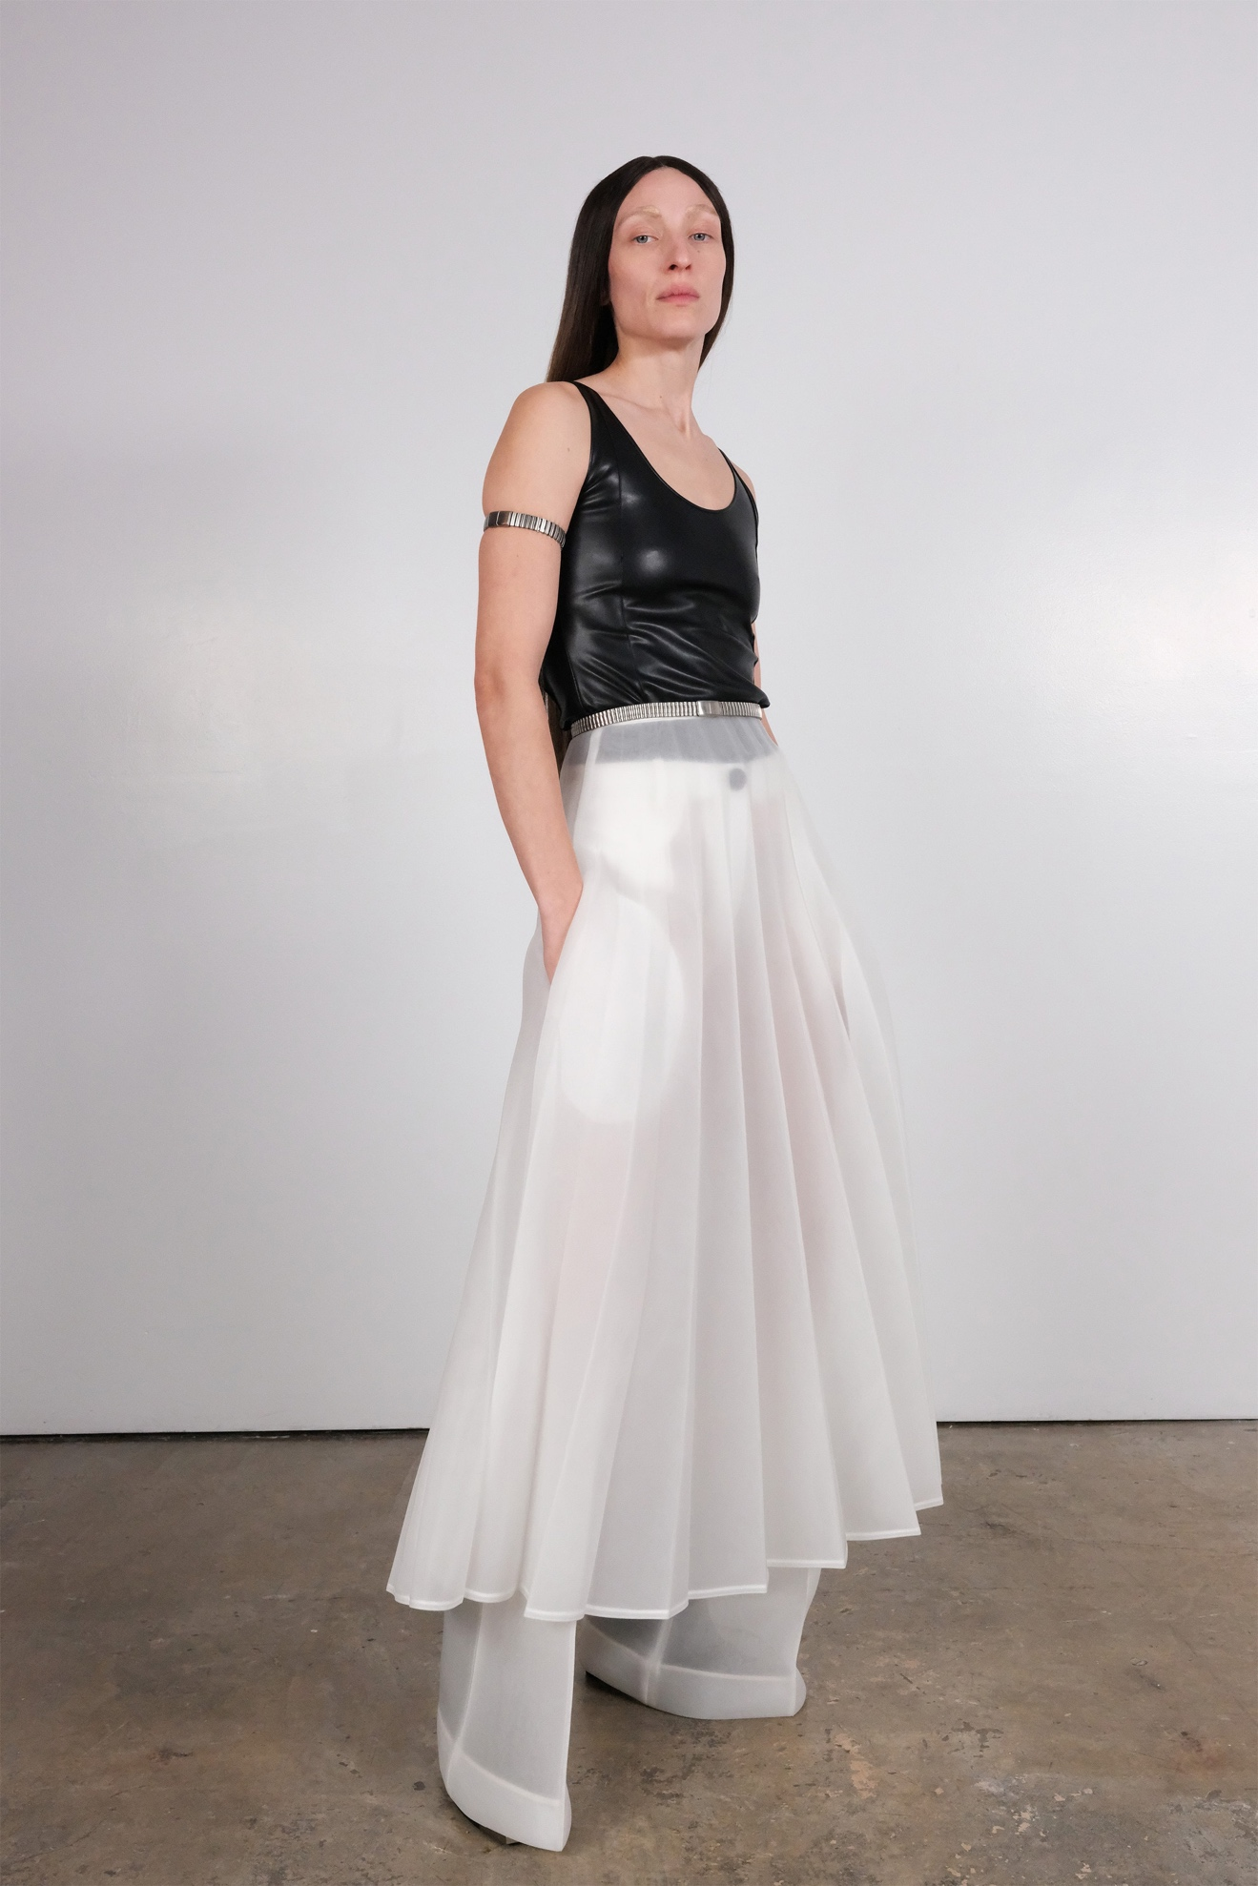Look 26](https://www.vogue.com/fashion-shows/fall-2020-ready-to-wear/peter-do/slideshow/collection#26)[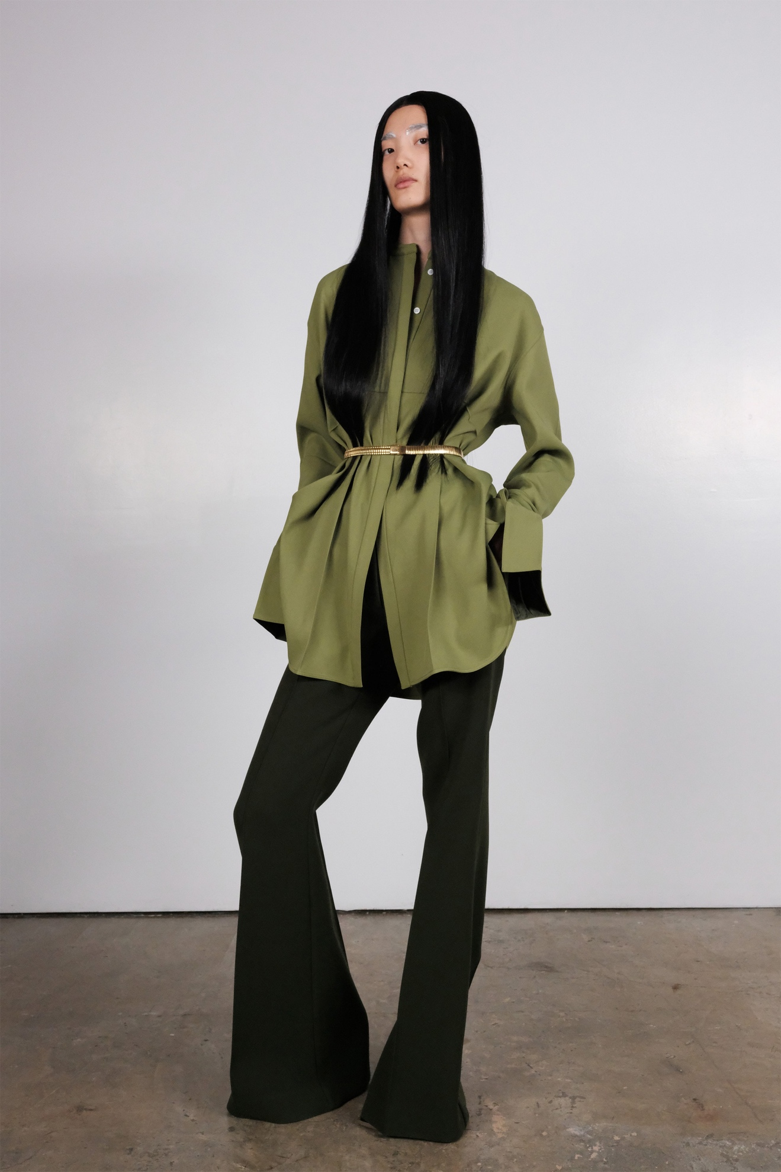Look 27](https://www.vogue.com/fashion-shows/fall-2020-ready-to-wear/peter-do/slideshow/collection#27)[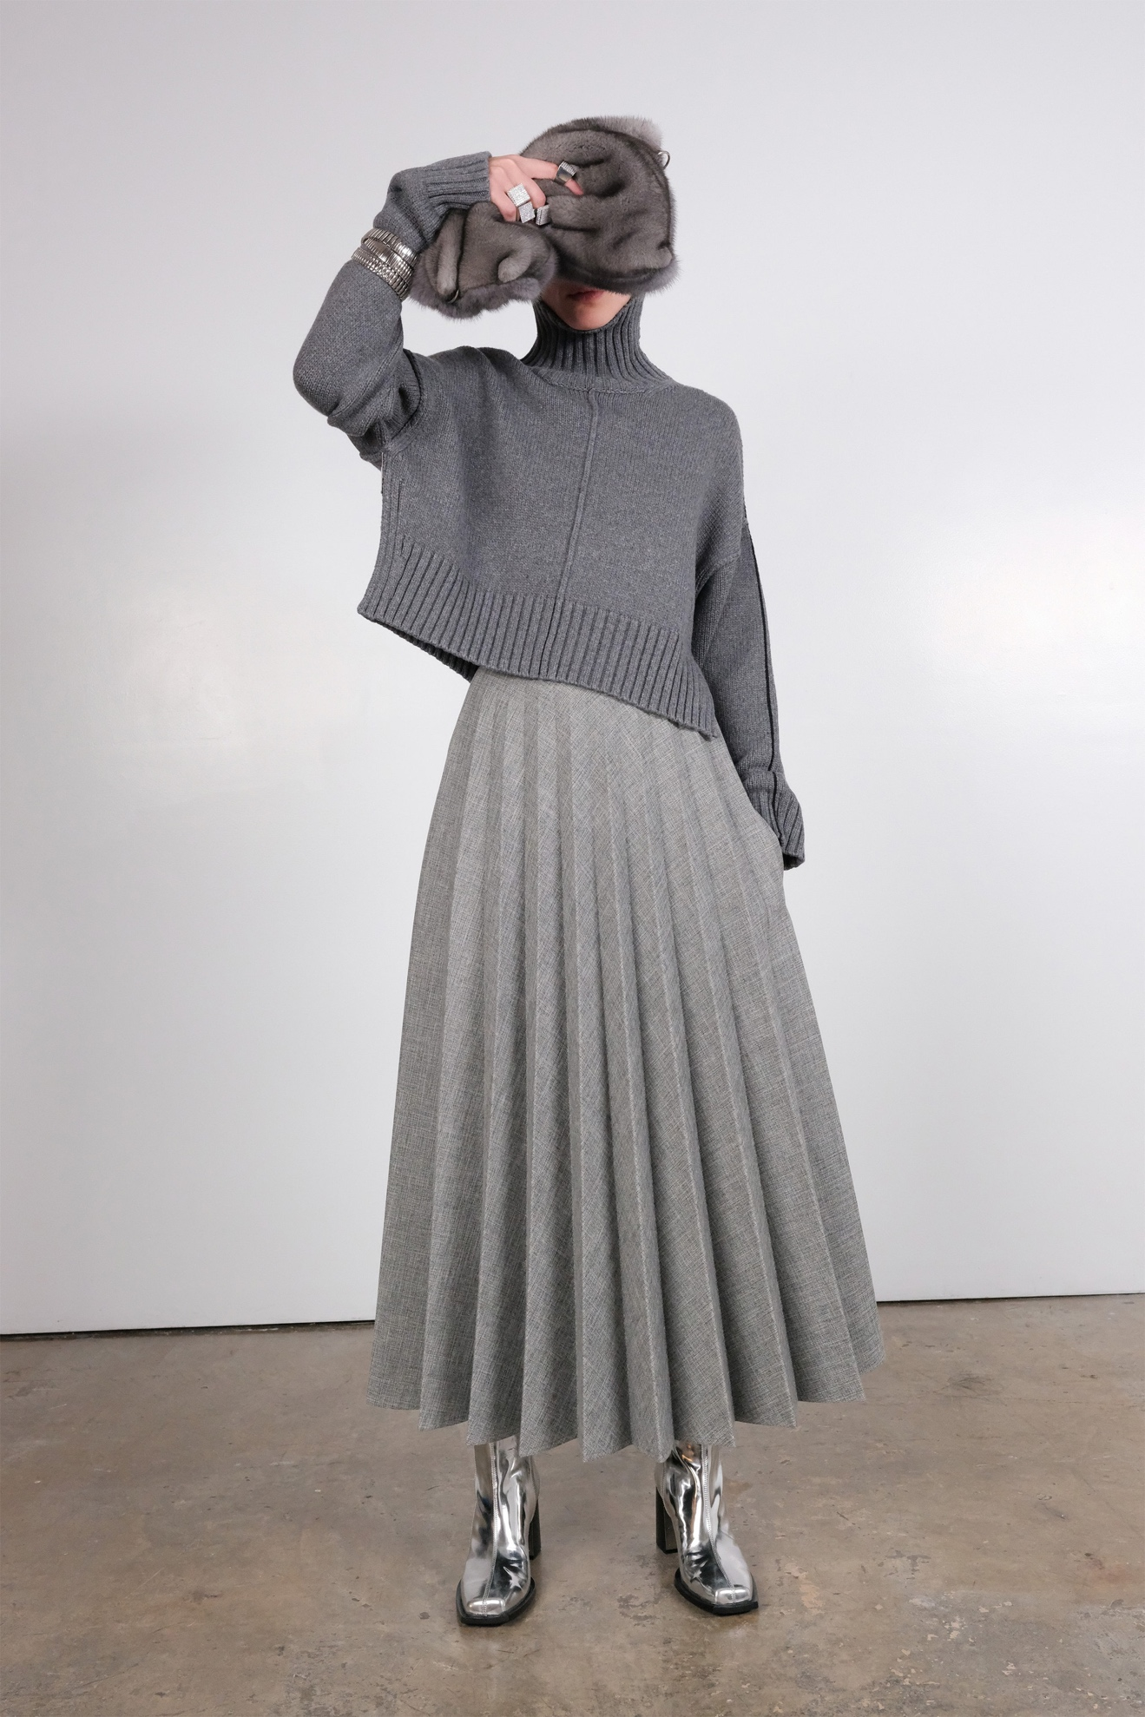Look 28](https://www.vogue.com/fashion-shows/fall-2020-ready-to-wear/peter-do/slideshow/collection#28)[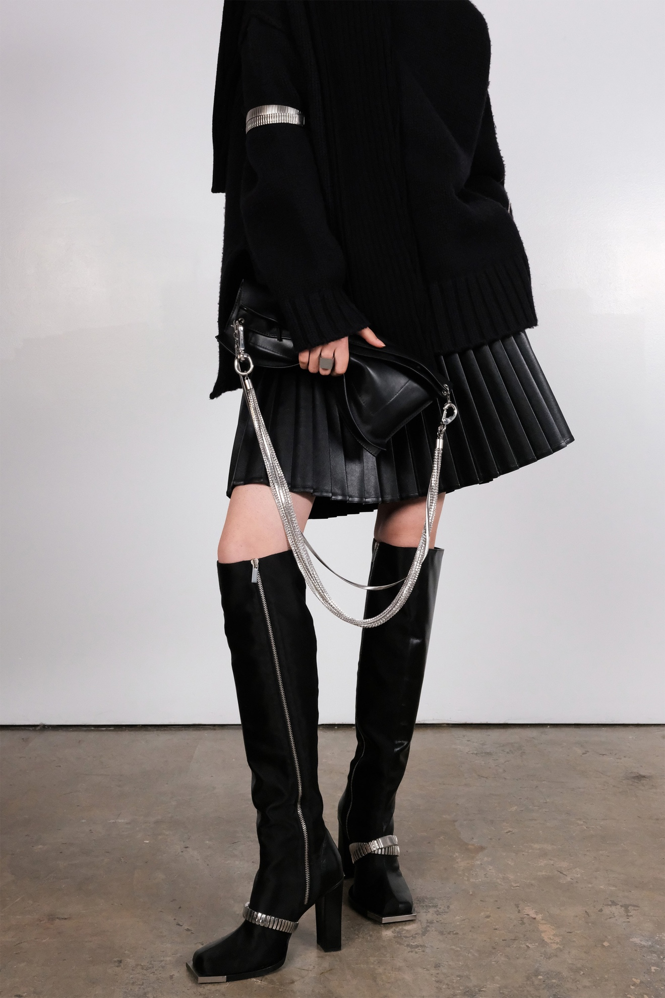Look 29](https://www.vogue.com/fashion-shows/fall-2020-ready-to-wear/peter-do/slideshow/collection#29)[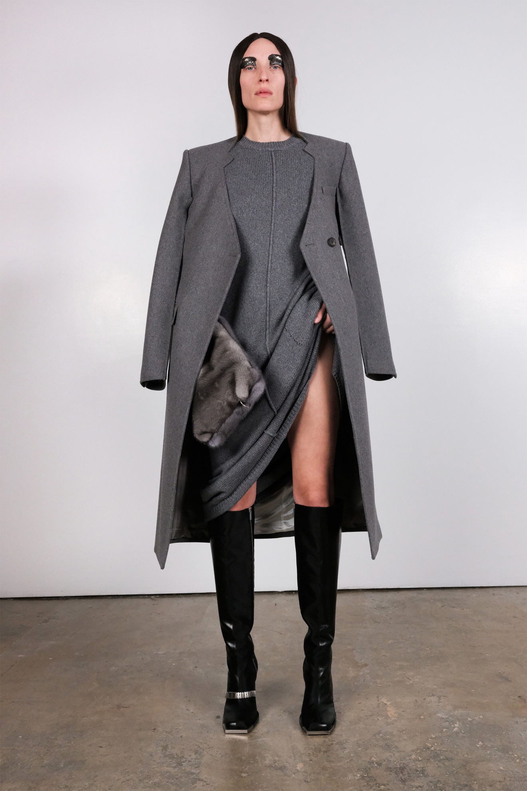Look 30](https://www.vogue.com/fashion-shows/fall-2020-ready-to-wear/peter-do/slideshow/collection#30)[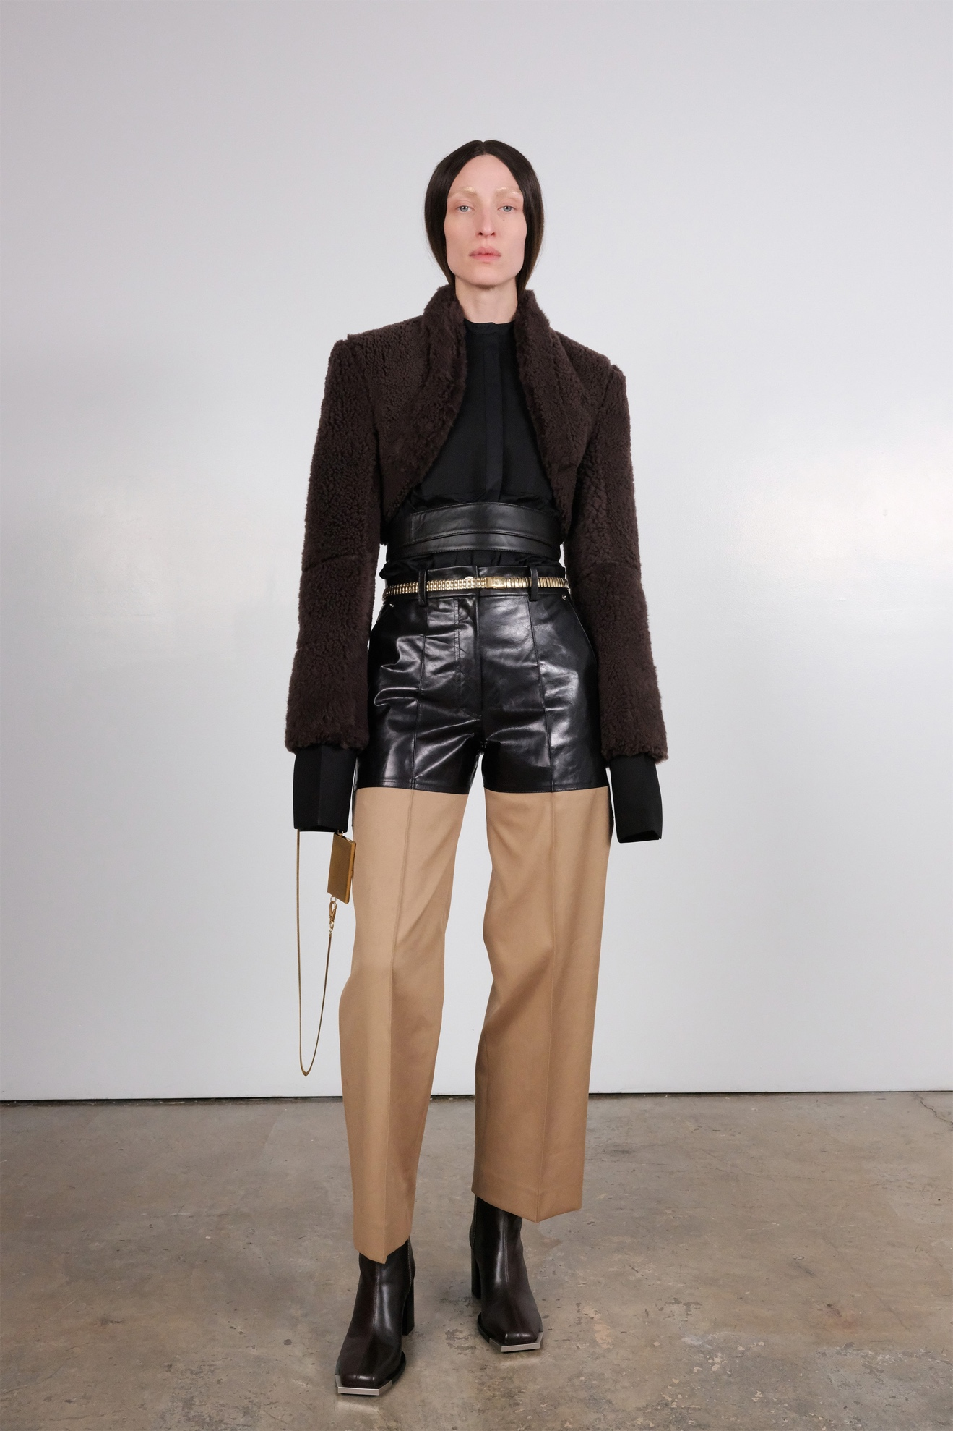Look 31](https://www.vogue.com/fashion-shows/fall-2020-ready-to-wear/peter-do/slideshow/collection#31)[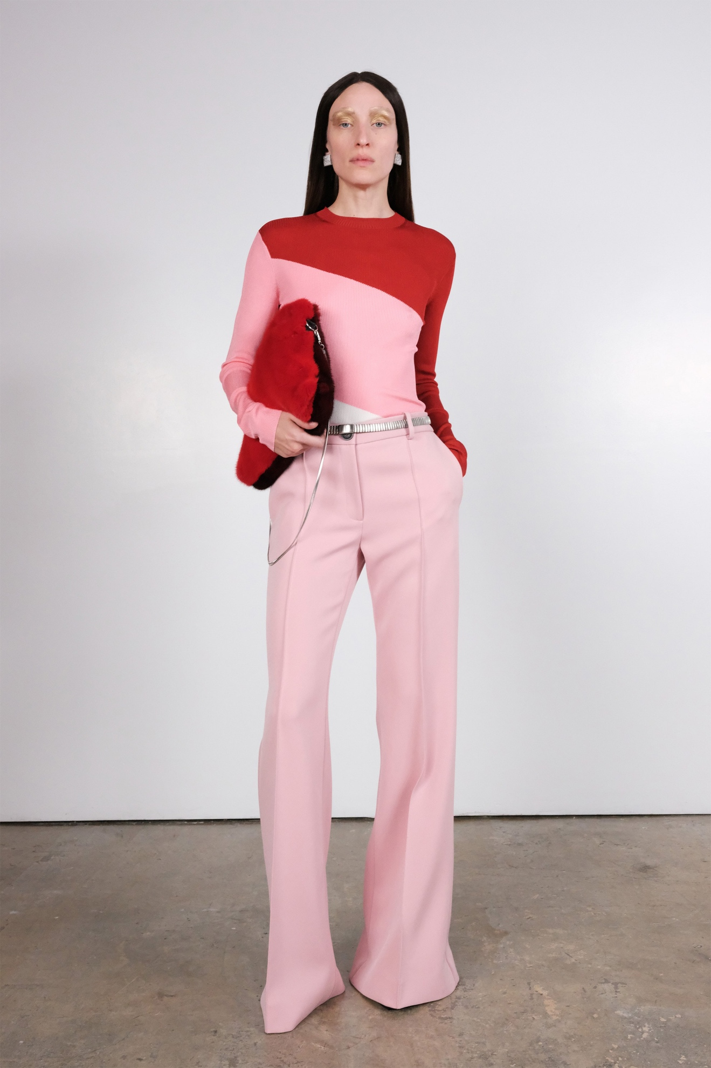Look 32](https://www.vogue.com/fashion-shows/fall-2020-ready-to-wear/peter-do/slideshow/collection#32)[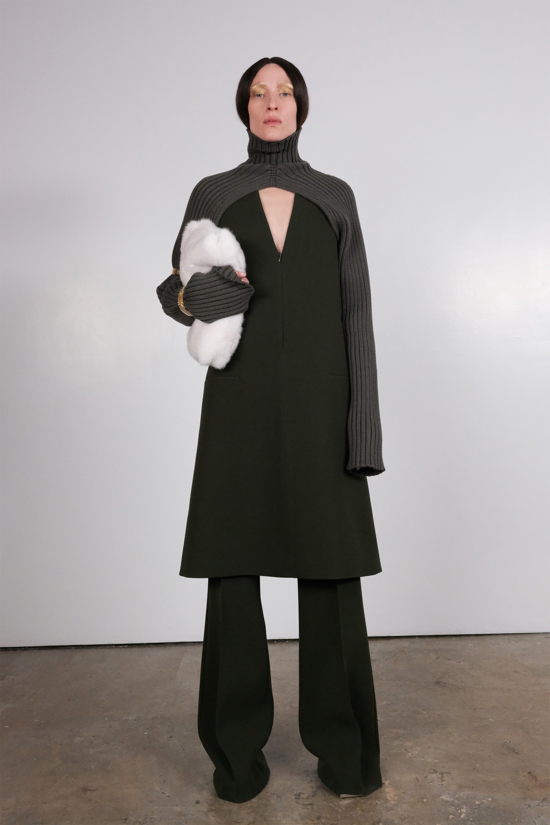Look 33](https://www.vogue.com/fashion-shows/fall-2020-ready-to-wear/peter-do/slideshow/collection#33)[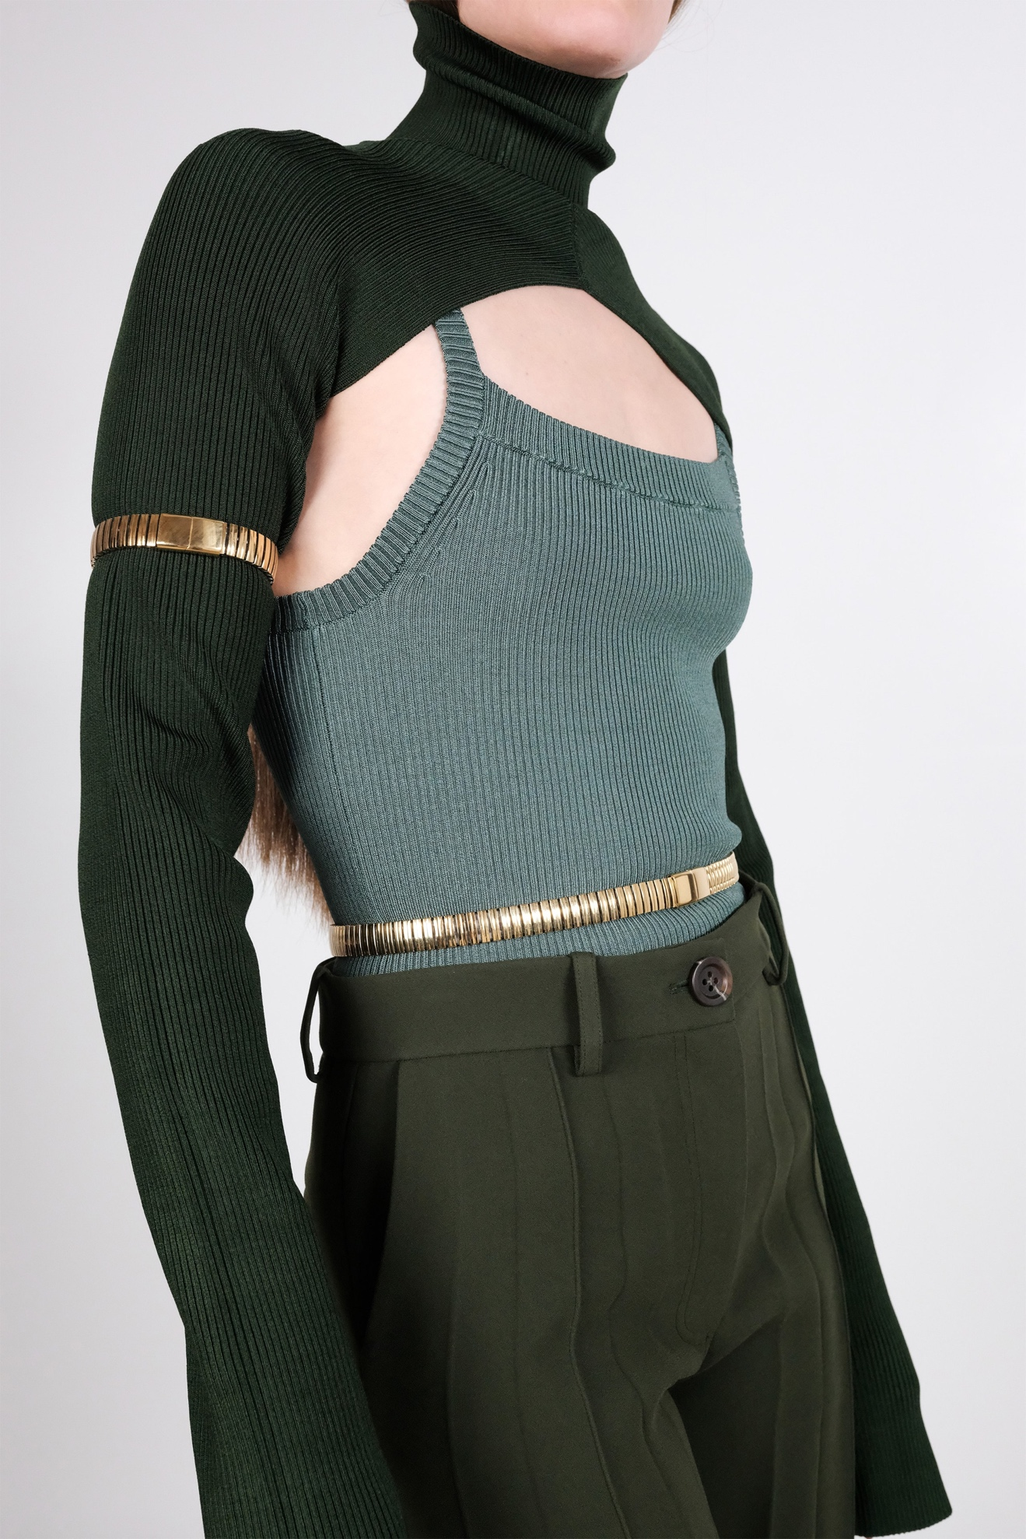Look 34](https://www.vogue.com/fashion-shows/fall-2020-ready-to-wear/peter-do/slideshow/collection#34)[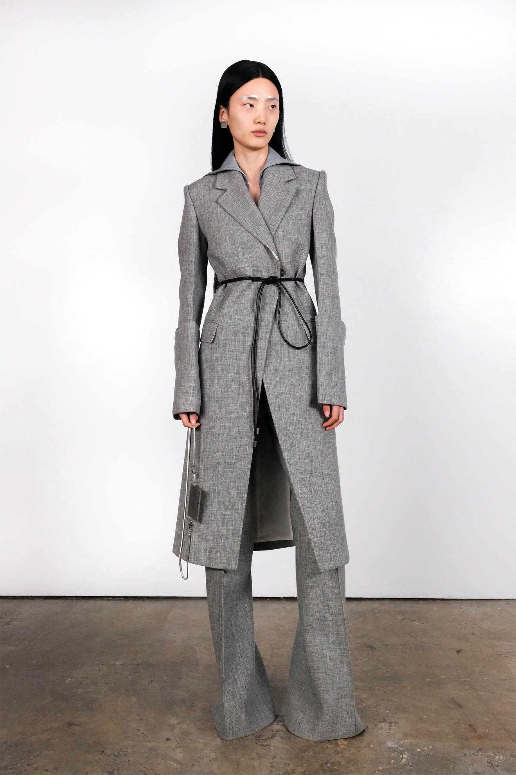Look 35](https://www.vogue.com/fashion-shows/fall-2020-ready-to-wear/peter-do/slideshow/collection#35)[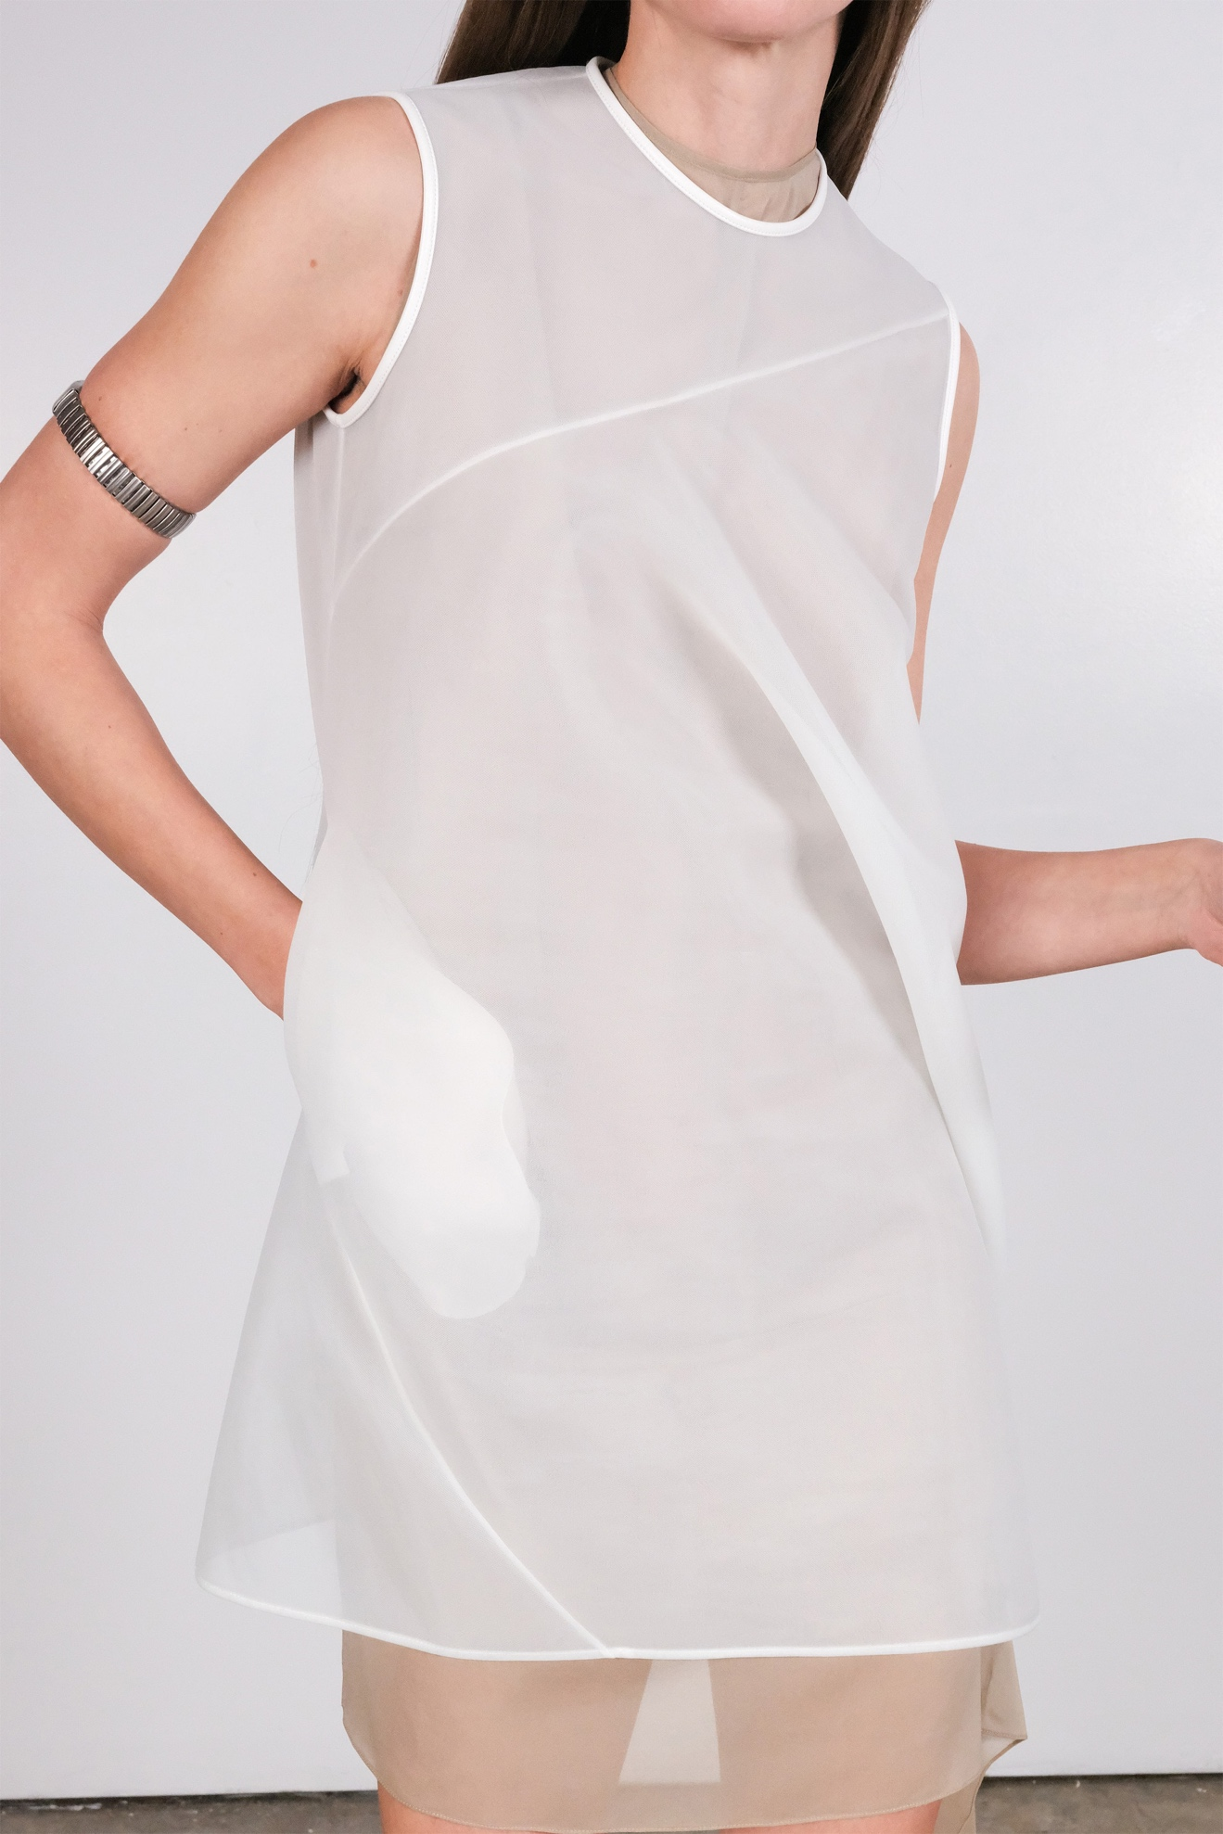Look 36](https://www.vogue.com/fashion-shows/fall-2020-ready-to-wear/peter-do/slideshow/collection#36)[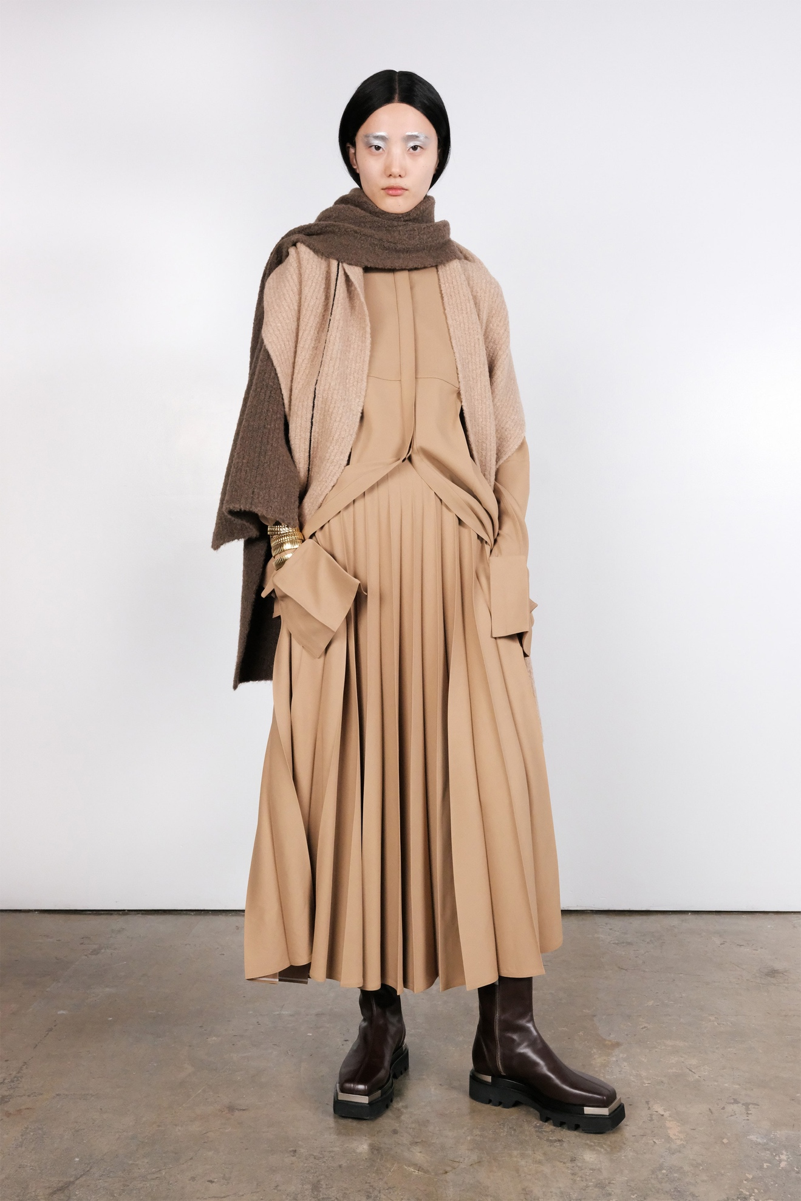Look 37](https://www.vogue.com/fashion-shows/fall-2020-ready-to-wear/peter-do/slideshow/collection#37)